2024-2025 EDUCATIONAL YEAR … SECONDARY SCHOOL
1ST TERM 1ST INDIVIDUALIZED WRITTEN EXAM FOR 7th GRADE

NAME-SURNAME:
CLASS-NUMBER: 7/
https://www.ingilizceciyiz.com/

A- Resime bakın. Uygun kelimeyi yuvarlak içine alın. (20p)


1- She has LONG / SHORT hair.
2- She looks UGLY / BEAUTIFUL.
3- She is OLD / YOUNG
4- She is BLACK / BLONDE.

B- Spor isimlerini uygun resimlerin altına yazınız. (30p) https://www.ingilizceciyiz.com/ ps://www.ingilizceciyiz.co

- volleyball - swimming - football - basketball - tennis - boxing

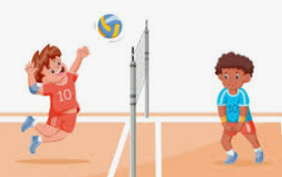
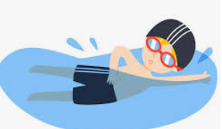
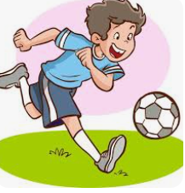

____________________ ____________________ ____________________
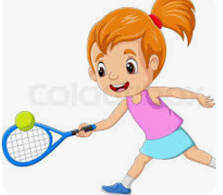
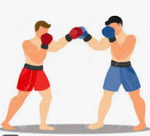
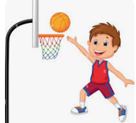

____________________ ____________________ ____________________
C- Doğru seçeneği işaretleyiniz. (50p)
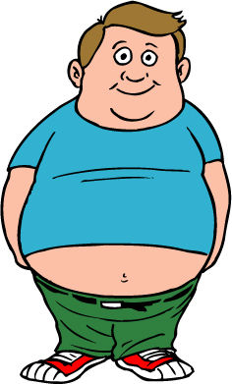
1-
a) He has got short brown hair. He is fat.
b) She has got grey hair. She is old.


2-
a) She has got glasses. She is ugly
b) She has got long wavy hair. She is very beautiful.


3- What is this?
a) It is a helmet.
b) It is a ball.
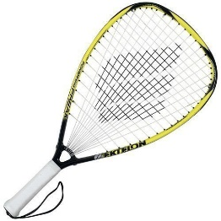
4- What sport can you play with this equipment?
a) Basketball
b) Tennis

5- Aşağıdakilerden hangisi “outdoor” (dışarıda oynanan) spordur.
a) b)

c) d)

OKAN GÜLTEKİN

