2024-2025 EDUCATIONAL YEAR … SECONDARY SCHOOL
1ST TERM 1ST INDIVIDUALIZED WRITTEN EXAM FOR 6th GRADE

NAME-SURNAME:
CLASS-NUMBER: 6/

A- Resimlerin altına yiyeceklerin İngilizcelerini yazınız. (30p)
- toast - salami - omelette - egg - sausage

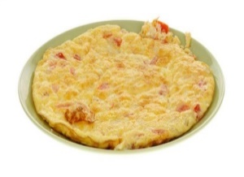
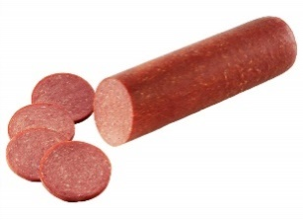
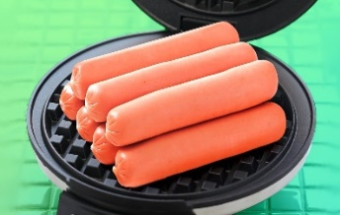
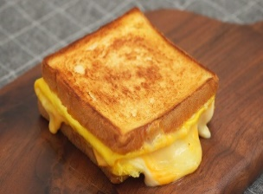
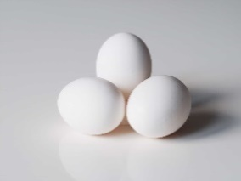

______ ____________ ____________ ___________ ____________
https://www.ingilizceciyiz.com/
B- Aşağıdaki kelimeleri resimlerin altına uygun düşecek şekilde yazınız. (30 p)
- have breakfast – take care of dog – play piano – play football – go to school

 |  |  | 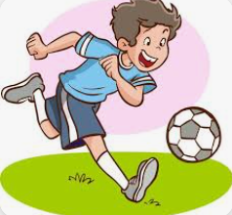 | 
……………………….. | ……………………… | ……………………….. | ……………………….. | ………………………..

C- Saatlerle İngilizce karşılıklarını eşleştiriniz. (20 p)
- 1.00 It is ten o’clock.

- 5.00 It is one o’clock.

- 10.00 It is five o’clock.

- 6.30 It is half past six.

C- Doğru şıkkı işaretleyiniz (20 p)
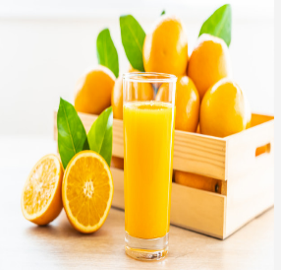
1.
a) I like orange juice.
b) I like milk.

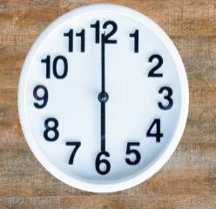
2. What time is it?

a) It is twelve o’clock.
b) It is six o’oclock.


3.
Hello! I’m Mete. My favourite food is pancake at breakfast and I like tea. I don’t drink milk or orange juice at breakfast.


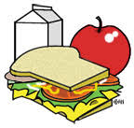
a) b)

https://www.ingilizceciyiz.com/


4.
a) She reads book.
b) She plays volleyball.

OKAN GÜLTEKİN

