2024-2025 EDUCATIONAL YEAR … SECONDARY SCHOOL
1ST TERM 1ST INDIVIDUALIZED WRITTEN EXAM FOR 5th GRADE

NAME-SURNAME:
CLASS-NUMBER: 5/

A- Resimlerin altına derslerin İngilizcelerini yazınız. (20p)
Art Turkish English Maths Music







________ _______ __________ ________ _________

B- Soruları cevaplarıyla eşleştiriniz. (20) https://www.ingilizceciyiz.com/

1-What is your name? (___) A- I’m ten years old.
2-How old are you? (___) B- I’m from Ankara.
3-Where are you from? (___) C- My name is Asya.
4- What is your favourite class? (___) D- My favourite class is P.E.

C- Resimlerin altına yerlerin İngilizcelerini yazınız. (20p)

1- library 2- hospital 3- cafe 4- school






_____________ ________________ _______________ ____________

D- Doğru seçeneği işaretleyiniz. (40p)


1- Where is the apple?
a) It is in the box.
b) It is in front of the box.


2- He likes doing sport so he likes __________.
a) English
b) P.E.



3-
a) I like swimming.
b) I don’t like swimming.

4- The dog is in the box. https://www.ingilizceciyiz.com/
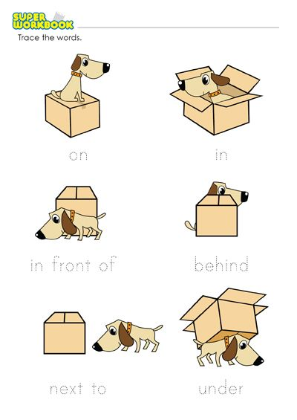
a) b)

OKAN GÜLTEKİN
ingilizceciyiz.com

