2024-2025 EDUCATIONAL YEAR
1st TERM 1st ENGLISH LISTENING EXAM FOR 8th GRADES
Name Surname: Number / Class:

A- Listen and circle what Barbara orders on the menu.
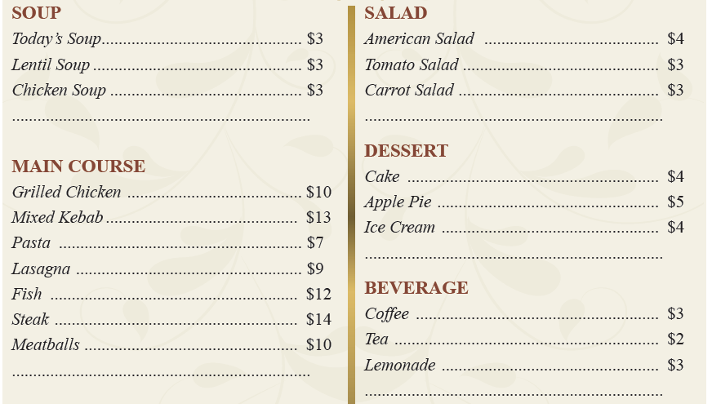

B- Listen to the rest of the conversation and write down what Adam orders.
