… EDUCATION YEAR …………………… SECONDARY SCHOOL 7th GRADE ENGLISH 1st TERM 1st WRITTEN EXAM
Name-surname :…………………………………………. Class : 7-….. No:…..

- Read the text and answer the questions. ( Aşağıdaki sorulara sadece isim yazarak cevap verin. )

Hi ! I’m Mary. I am a 7th grade student. I have two close friends, Jennifer and Rose. Jennifer is tall and slim. She is beautiful with long dark hair and hazel eyes. She always tells the truth and she makes jokes. Rose is of medium weight and short. She has curly hair and big eyes. She is cute. She never changes her mind easily. She always does her homework on time and studies hard but I don’t.

1. a) Who is lazy?..........................................
b) Who is honest?.......................................
2. a) Who is cute ?..........................................
b) Who has hazel eyes ?.............................

- Read the text and answer the questions. ( Aşağıdaki soruları metne göre cevaplayın. )

Betty and Lucy are sisters, but they are very different. Betty has short wavy blonde hair and brown eyes. Lucy is short with straight fair hair and blue eyes. Betty is more outgoing than Lucy. She has a lot of friends, and she enjoys spending time with them. Lucy likes drawing pictures at home.

1. a) What does Lucy look like? ..........................................................................................
b) What is Betty like? ......................................................................................................
2. a) What does Lucy like ? ……………………………………………………………….
b) Who is more outgoing ? ..............................................................................................

- Read the text and answer the questions. ( Aşağıdaki soruları metne göre cevaplayın. )

Hi I’m Susan. I’m a tennis player. I get up early every day. I always eat healthy food. Then, I go to the tennis court to train six times a week. I have a racket to play tennis. I want to win a gold medal at Olympics.

1. Does Susan get up late?..................................................................
2. How often does Susan train?..........................................................
3. Which equipment does Susan have?..............................................

- Answer the questions about your daily routine. ( Aşağıdaki iki soruyu kendinize göre cevaplayın. )

1. How often do you read books ? ……………………………………………………………
2. What do you do after school? ……………………………………………………………...

- Compare Ronaldo and Messi according to the information in the table below. ( Tablodaki bilgilere göre iki futbolcuyu karşılaştıran tam cümleler yazın. Sadece 2 cümle. )

 | RONALDO  Date of birth: 1985  Height: 1.85 m  Weight: 83 kg | MESSI  Date of birth: 1987  Height: 1.70 m  Weight: 72 kg

………………………………………………………………………………………………………………………………………………………………………………………………………………………………………………………………………………………………………………………………………………………
- Look at the table below and make sentences by using the frequency adverbs. ( Verilen bilgilerle örnekteki gibi cümleler yazın. )

 | get up early | eat healthy food | drink fizzy drinks
Tom | ⭐⭐⭐⭐ | ⭐
Andy |  |  | ⭐⭐
Susan | ⭐⭐⭐⭐⭐
Example: Tom rarely eats healthy food.
- Tom...................................................................................
- Andy................................................................................ ..
- Susan.................................................................................

- Read the text and answer the questions. ( Aşağıdaki soruları metne göre cevaplayın. )
Archery is a target sport. It is an outdoor sport. You need arrows and bow. The archer tries to hit the target and get high points. You should wear your arm guard and use your finger tab while shooting.

1. What is the name of the sport ? ……………………………………………………
2. Is it an indoor sport ? ................................................................................................

- Write the names of equipments. ( Metni tekrar okuyun ve aşağıdaki ekipmanların isimlerini doğru resmin altına yazın. )
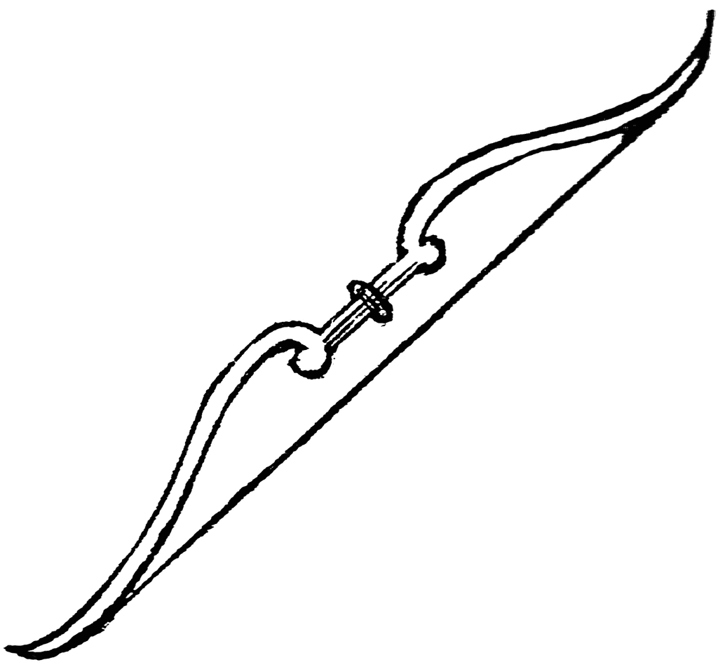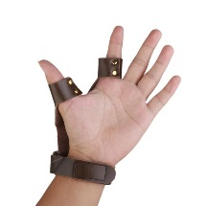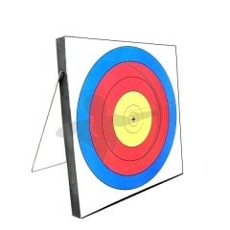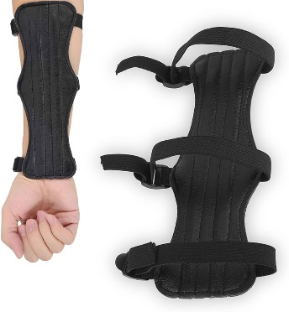

Not : Her doğru cevap 4 puandır.
Nurgül ARAS

