Full name/Class: Mark:
… ACADEMIC YEAR 1ST TERM 1ST ENGLISH EXAM (READING & WRITING)
PART 1: Fill in the gaps with suitable words. (5x2=10p)
1- A bow and an arrow are the equipment for ....................................... .
2- In this competition, the winners get bronze, silver and gold ...................................... in the end.
3- The match ended in a .................................... . The score was 3-3.
4- We use a ball and a .................................. to play tennis.
5- People wear ..................................... when they go to the sea or pool.
PART 2: Look at the table below and make sentences by using the frequency adverbs. (5x2=10p)
 | Get up early | Play tennis | Drink milk
Lucy | ⭐⭐⭐⭐⭐ | ⭐ | ⭐⭐
Wesley | ⭐⭐⭐ | ⭐⭐⭐⭐ | ⭐
Example: …Lucy always gets up early...................................... (get up early)
- …Lucy................................................................................. (play tennis)
- …Lucy................................................................................. (drink milk)
- ...Wesley................................................................................. (get up early)
- ...Wesley................................................................................. (play tennis)
- ...Wesley................................................................................. (drink milk)
PART 3: Fill in the blanks with personality adjectives. (5x2=10p)
- Somebody who never changes mind: ____________________ .
- Somebody who likes sharing and buying presents for people: ____________________ .
- Somebody who always goes somewhere on time: ____________________ .
- Somebody who speaks a lot: ____________________ .
- Somebody who doesn’t like studying/working: ____________________ .
PART 4: Read the text and answer the questions. Make sentences. (6x2=12p)
Luna and Olivia are cousins. They are totally different. Luna is outgoing and helpful. Olivia is selfish and mean. Luna is short and slim. Olivia is tall and plump. Luna enjoys playing the guitar in her free time and Olivia likes watching TV.
- What does Luna look like? __________________________________________________________ .
- What is Olivia like?__________________________________________________________ .
- What does Luna like?__________________________________________________________ .
- What does Olivia look like?__________________________________________________________ .
- What is Luna like?__________________________________________________________ .
- What does Olivia like? __________________________________________________________ .
PART 5: Compare Ronaldo and Messi according to the information in the table below. (4x2=8p)
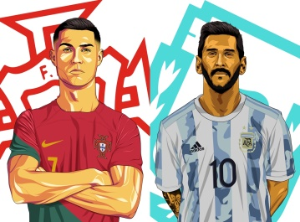 | RONALDO  Date of birth: 1985  Height: 1.85 m  Weight: 83 kg | MESSI  Date of birth: 1987  Height: 1.70 m  Weight: 72 kg | 1)Ronaldo is ............................................................... Messi. (age)  2)Messi is …........................................................... Ronaldo. (height)  3)Ronaldo is ….......................................................... Messi. (weight)  4)Messi is …............................................................ Ronaldo. (age)

