2024-2025 EDUCATIONAL YEAR
1st TERM 1st ENGLISH LISTENING EXAM FOR 7th GRADES
Name Surname: Number / Class:

Listen and write their names; Janet, Peter, Emma or Robert.
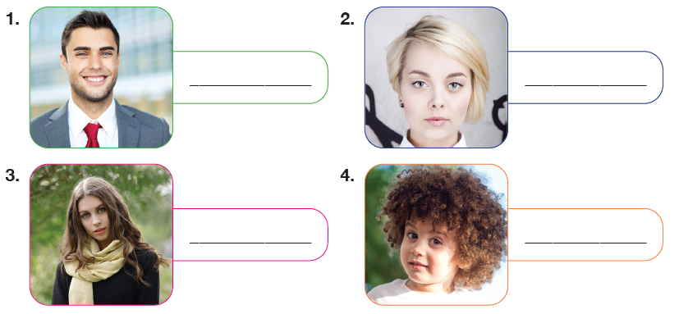

B- LISTEN AND FILL IN THE BLANKS
Hello. I'm Rachel. I'm ___________________ 1) and ___________________ (2). My friends say I'm ___________________ (3) with ___________________ (4) hair and blue eyes. I have a brother. He doesn't look like me. He's ___________________ (5) and more ___________________ (6) than me. He's very popular among his friends because he can play football ___________________ (7)
than everyone else.

