2024-2025 EDUCATIONAL YEAR
1st TERM 1st ENGLISH LISTENING EXAM FOR 7th GRADES
Name Surname: Number / Class:

Listen and write their names; Janet, Peter, Emma or Robert.
1- ROBERT 2- JANET 3- EMMA 4- PETER
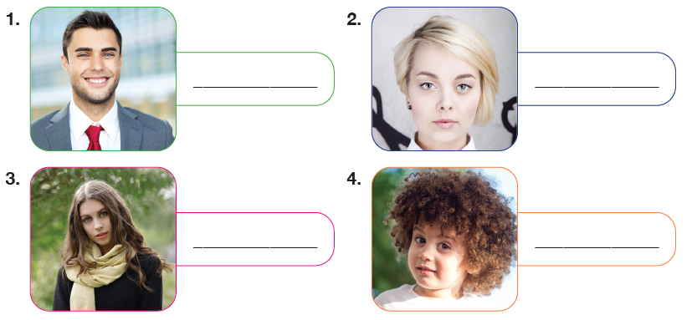

B- LISTEN AND FILL IN THE BLANKS
Hello. I'm Rachel. I'm _________TALL__________ 1) and ____SLIM_______________ (2). My friends say I'm ______BEAUTIFUL_____________ (3) with _______CURLY____________ (4) hair and blue eyes. I have a brother. He doesn't look like me. He's _____YOUNGER______________ (5) and more ________OUTGOING___________ (6) than me. He's very popular among his friends because he can play football ____BETTER_______________ (7)
than everyone else.

