2024-2025 EDUCATIONAL YEAR
1st TERM 1st ENGLISH LISTENING EXAM FOR 7th GRADES
Name Surname: Number / Class:

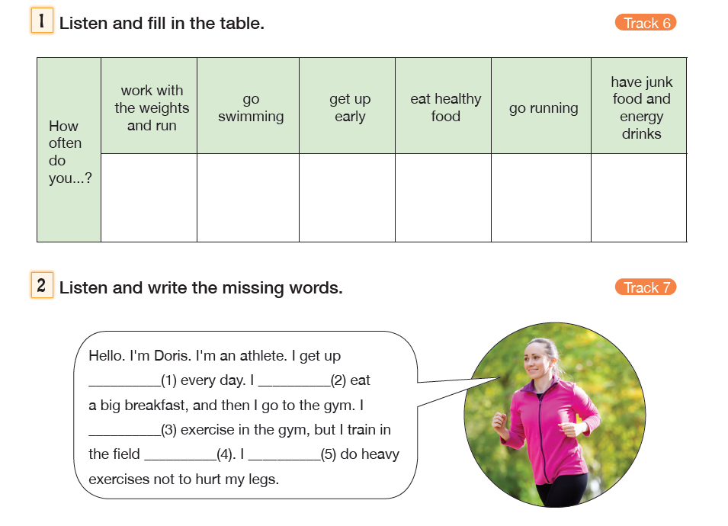

TWO DAYS A WEEK
ALWAYS
THREE DAYS A WEEK
NEVER
USUALLY
FIVE DAYS A WEEK

1- EARLY
2- USUALLY
3- SOMETIMES
4- MORE OFTEN
5- NEVER

