2024-2025 EDUCATIONAL YEAR
1st TERM 1st ENGLISH LISTENING EXAM FOR 5th GRADES

Listen to Nancy and complete her timetable. (10*10P=100P)

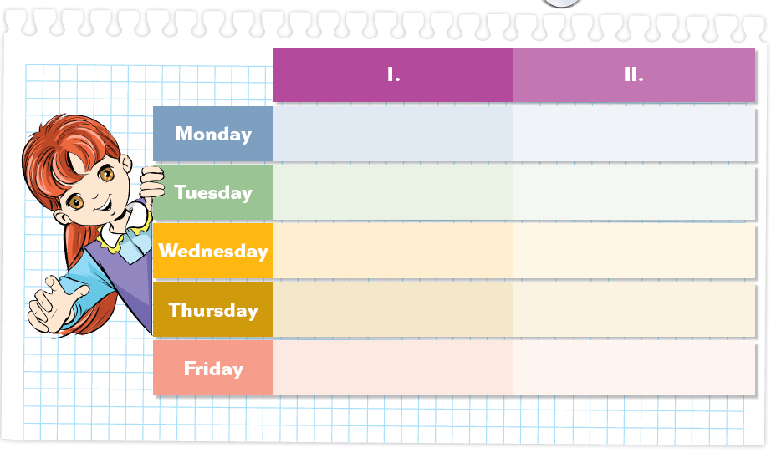
maths
history
Geography
English
Music
science
P.E.
history
science
art

