2024-2025 EDUCATIONAL YEAR
1st TERM 1st ENGLISH LISTENING EXAM FOR 5th GRADES

Name Surname: Number / Class:
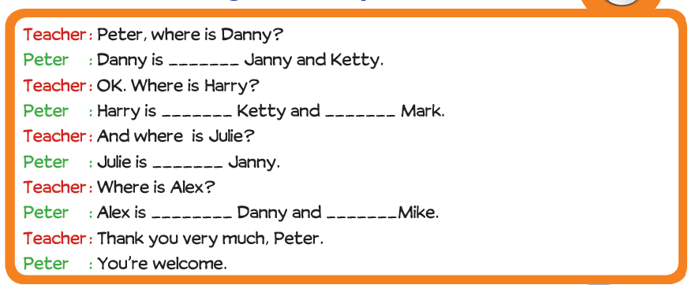
A- Listen to the dialogue and complete the sentences.


B- Listen to the dialogue again and write the names of the students.

