_________________________ VOCATIONAL AND TECHNICAL ANATOLIAN HIGH SCHOOL 2024- 2025 EDUCATIONAL YEAR 1ST TERM 1ST INDIVIDUALIZED WRITTEN EXAM FOR 12TH GRADES

NAME SURNAME:
NUMBER/CLASS:
Match the questions with the answers. ( soruları cevaplarıyla eşleştiriniz) 4x10= 40
- What are your music preferences? A) I’m afraid,I disagree. ____
- What are the qualities a good friend/people? B) I’d prefer singing well. ____
- Would you prefer playing any musical instrument or singing well? C) Pop and energetic music. ___
- In my opinion, folk music is better than the others. D) Supportive, reliable, honest. ___
Match the sentences with the pictures. 4x15= 60
A B C D
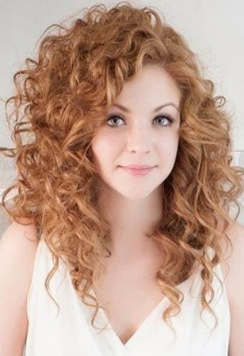

- She is young, pretty and happy. She has got long curly hair. ________
- He is middle-aged and fat. ________
- She is old woman, she is short and unhappy. She wears glasses. ________
- Young man has got mustache and beard. He is gentle and handsome. He wears hat. _______

GOOD LUCK😊

______________ _________________ ________________
ELT ELT Okul Müdürü

