_________________________ VOCATIONAL AND TECHNICAL ANATOLIAN HIGH SCHOOL 2024- 2025 EDUCATIONAL YEAR 1ST TERM 1ST INDIVIDUALIZED WRITTEN EXAM FOR 11TH GRADES

NAME SURNAME:
NUMBER/CLASS:
Circle the correct option. ( Dogru seçeneği daire içine alınız.) 5x8= 40
- I would rather / prefer staying at home to going out.
- She prefer / would rather watch Tv than read a book.
- I will / could graduate from the high school after two years.
- When I was a child I could / can sleep easily.
- My mother will / won’t make a cake tomorrow, because we will go to picnic.
Match the sentences with the pictures. 4x15= 60
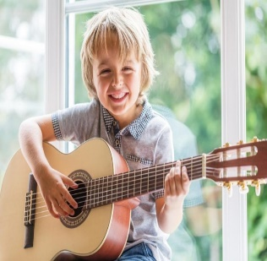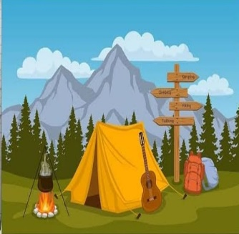
________________ ______________ _________________ _________________

- Susan enjoys painting in her free time
- We love camping with our friends on the weekend.
- Their little baby likes swimming .
- My brother is gifted in playing the guitar.

GOOD LUCK😊

______________ _________________ ________________
ELT ELT Okul Müdürü

