__________________________ VOCATIONAL AND ANATOLIAN HIGH SCHOOL 2024-2025 EDUCATIONAL YEAR 1ST TERM 1ST INDIVIDUALIZED WRITTEN EXAM FOR 10TH GRADES

NAME SURNAME: NUMBER/CLASS:
- MATCH THE CORRECT ANSWER ( DOĞRU CEVABI EŞLEŞTİR)
1)What is your name? A) I am 16 years old
2)How old are you? B) I am from Bosnia
3)Where are you from? C) My name is Lisa
4) Where do you work? D) I work in a bank
B. MATCH THE SENTENCES (DOĞRU CEVABI EŞLEŞTİR)
1) I have ……………….. a) English
2) I get up at ………………. b) a computer
3) I live in …………………. c) Istanbul
4) I like …………….. subject d) 8 a.m
C. MAKE SENTENCES (AŞAĞIDAKİ KELİMELERİ KULLANARAK CÜMLE YAP)
1) you /a successful student/ are …………………………………………………………….
2) live / in / I / a village ………………………………………………………
3) buy / I/ new mobile phone / will …………………………………………………………..
4) he / to Ankara/ is going to go …………………………………………………………..

D. MATCH THE PICTURES WITH THE SUBJECTS ( DERSLER İLE RESİMLERİ EŞLEŞTİR)
ENGLISH - PHYSICAL EDUCATION - MATHS - SCIENCE - ART
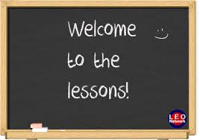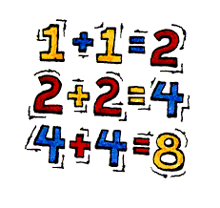
GOOD LUCK😊

______________ _________________ ________________
ELT ELT Okul Müdürü

