………………………. ORTAOKULU
5.
SINIF
PUAN:

İNGİLİZCE Soyadı …………………………………………
2. DÖNEM 2. YAZILI Sınıfı …………………. No …………………. ………………
1. Soru  (10 Puan) | 2. Soru  (10 Puan) | 3. Soru  (10 Puan) | 4. Soru  (10 Puan) | 5. Soru  (10 Puan) | 6. Soru  (10 Puan) | 7. Soru  (10 Puan) | 8. Soru  (10 Puan) | 9. Soru  (10 Puan) | 10. Soru  (10 Puan) | Aldığı  Puan
………… | ………… | ………… | ………… | ………… | ………… | ………… | …….. | ------- | --------- | …….
Aşağıda verilen açık uçlu soruları cevaplayınız

S1 |  | S3
Read the text and answer  Hide-and-Seek  It’s a popular outdoor game. A lot of children can  play it together. First, you pick a friend, ‘it player’. He goes to a tree. This place is the base. ‘It player’ counts from 1 to 50. The children go and hide. ‘It’ finds the other children, say children’s names and touch the base.  1) What kind of game is it?  ………………………………………  2) How many children can play it together ?  ……………………………………… |  | Dear Linda,  I am Peter. I am 10 years old. I am from Holland. I am on our farm with my family. We have lots of animals like cows, sheep, horses, and chickens. Everybody should work hard on the farm. My sister, Sue, is milking the cows. My mum, July, is collecting the eggs. My father is watering the flowers. My brother, Joe, is feeding the rabbits. I hope you will come and meet us one day. I am looking forward to hearing from you. With love from Holland Peter  Which animal is Joe feeding?  ………………………………………………………………  What is Peter’s sister’s name?  ………………………………………………………………  How many people are there on the farm?  ………………………………………………………………

S2 |  | S4
Read the text and complete the sentences.  Hello, I’m Arthur. I like watching movies . I like western movies. My favourite film is ‘Wild West’. Cowboys are brave people. Also, I like adventure films, because they are interesting and exciting. I hate horror films. They are horrible and boring. My sister, Nancy likes romantic films. She thinks they are great. Her favourite film is ‘Pretty Woman’. She doesn’t like war and documentary movies. She thinks they are not interesting.  1) What does Arthur like watching?  ................................................................  2) What kind of films does Arthur hate?  .................................................................  3) What is Nancy’s favourite film?  ............................................................ |  | Betty : Science fiction movies are my favourite.  Robert : I love watching animations and horror movies.  Daisy : I don’t like action movies. I think they are boring.  Samuel : Watching comedy movies is exciting and great.  Who likes watching frightening movies?  ……………………..

S5 |  | S8
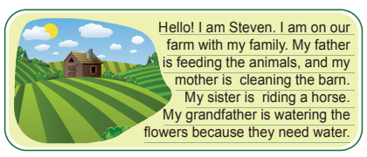  Where are Steven and his family?  ………………………………………………………..  Who is cleaning the barn on the farm now?  ………………………………………………………..  Why is his grandfather watering the flowers?  ……………………………………………………….. |  | 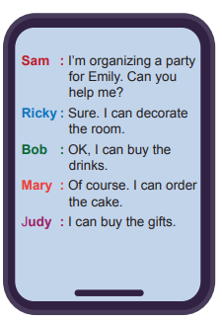  According to the conversation, who gets the presents?  ………………………………

S6 |  | S9
What kind of movies do you like?  ………………………………..  What is your favorite movie?  ………………………………..  Do you like horror films?  ……………………………….. |  | Thomas: I’m cleaning the cages now.  Lisa : I’m feeding the rabbits.  Andy : I'm doing my school project.  George : I’m bathing the horses.  Who is NOT doing any farm works now?  ………………………………

S7 |  | S10
  When is Anna’s birthday party? |  | Judy is going cycling on Sunday. She sends messages to her friends to invite them. Here are their responses:  Betty : That’s a good idea.  Tom : I’m sorry, but I can’t.  Clara : Sure, I like riding a bike.  Jack : Sorry, I am too tired.  According to the given conversation, who refuses the invitation by giving an excuse?  ………………………….
Not:Sınav süresi 40 dakikadır. …………………………….
sorubaktarafından hazırlanmıştır Ders Öğretmeni
Başarılar

