2023-2024 EDUCATIONAL ACADEMIC YEAR
MUSABEYLİ MULTI-PROGRAM ANATOLIAN HIGH SCHOOL
9th GRADERS 2nd TERM 1st ENGLISH EXAM
Name & Surname: Duration: 40 minutes
Class: Number: Date:

READING
A) Read the text below and answer the questions. (5x4=20 points)
Ahmet : Hello, Brian. This is Ahmet.
Brian : Hi, Ahmet. How is it going?
Ahmet : Fine. Brian, I’m coming to London to visit some tourist attractions.
Brian : Good news. When?
Ahmet : Next week. What do you advise me to do?
Brian : I advise you to visit London Bridge and Big Ben when you come to London.
Ahmet : What else?
Brian : Well, I strongly advise you to board the London Eye. It offers a wonderful view of a large part of London.
Ahmet : One more question. What’s the weather like in London?
Brian : It’s rainy almost every day in London. Don’t forget to bring your boots and raincoat.
Ahmet : Hmmm... That’s good. Thank you, Brian.
Brian : You are welcome, Ahmet. Take care, bye.
Ahmet : Bye.

- Why Ahmet calls Brian?
__________________________________________________________________________________________

- Where does Brian live in?
__________________________________________________________________________________________

- When will Ahmet go to England?
__________________________________________________________________________________________

- What is the weather like in England?
__________________________________________________________________________________________

- Which activities can Ahmet do in London?
__________________________________________________________________________________________

GRAMMAR
- Complete the sentences with “can” or “can’t” in brackets. (6x1= 6 pts.)
            - Catwoman [………….] change her appearance easily. She [………….] run very fast like a cat.
            - My favourite hero, Spiderman is very clever and brave. He [………….] climb fast like a spider.
            - Superman is very strong and brave. He [………….] see and hear everything and fly fast.
            - Allain is 15 years old and he hasn’t got any driving licence. So, he [………….] drive a car alone.
            - Chickens [………….] fly over the sky like other flying birds. Because they haven’t got such an ability.

VOCABULARY
- Match the vocabulary about types of movies with their correct definitions. (5x2=10 pts.)

passenger (.......) departure board (......) boarding pass(........) security check (........) jetway (........)

a) a search of a person and his/her baggage for any hidden weapons or explosives before entering an airport/bus station.
b) a card that a passenger must have in order to be allowed to get on an aircraft or a ship, bus etc.
c) a portable bridge placed against an aircraft door to allow passengers to get on and off.
d) a traveller on a public or private transportation other than the driver, pilot or crew.
e) a board in an airport/bus station displaying the times and destinations of future departures.

WRITING: Write at least 6 dialogues about weather conditions according to the given clues below. Ask and answer what the weather is like in those cities. (6x4=24 pts.)
Edirne | İzmir | Mersin | Konya | Erzincan | Gaziantep
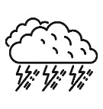 |  |  |  | 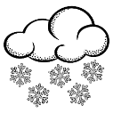 | 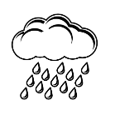

- A:…………………………………………………………………………………………………………………………
B:…………………………………………………………………………………………………………………………
- A:…………………………………………………………………………………………………………………………
B:…………………………………………………………………………………………………………………………
- A:…………………………………………………………………………………………………………………………
B:…………………………………………………………………………………………………………………………
- A:…………………………………………………………………………………………………………………………
B:…………………………………………………………………………………………………………………………
- A:…………………………………………………………………………………………………………………………
B:…………………………………………………………………………………………………………………………
- A:…………………………………………………………………………………………………………………………
B:…………………………………………………………………………………………………………………………

LISTENING
Listen to Emma talking about her housemates, and write your answers in the blanks for questions 1 to 10. (10x2= 20 pts.)
Robert

Sarah
Charlotte
Jason

- Who has got long, straight, dark hair? ………………
- Who is quiet and a little boring? ………………
- Who is noisy and loves loud music? ……………….
- Who is bald? ……………….
- Who is in about thirty? ……………….
- Who is tall and fat? ……………….
- Who is tidy and a little unfriendly? ……………….
- Who is slim and has long blonde hair? ……………….
- Who has brown eyes and curly hair? ……………….
- Who is kind and funny? ……………….

SPEAKING: You are going to work in pairs and imagine yourself at the restaurant. How would you order food? Create a dialogue and take or give an order. (20 points)
Student A
You are the customer.
Greet.
Ask for a table.
Ask for the menu and order food.
Ask for the bill.
Express your pleasure.
Student B
You are the waiter.
Greet.
Respond and show the table available.
Take the order and serve your customer.
Bring the bill.
Express your pleasure.

SPEAKING TASK EVALUATION CRITERIA
Fluency / Pronunciation (4)
Accuracy (4)
Grammar (4)
Vocabulary (4)
Relevance / Coherence (4)
TOTAL
(20)
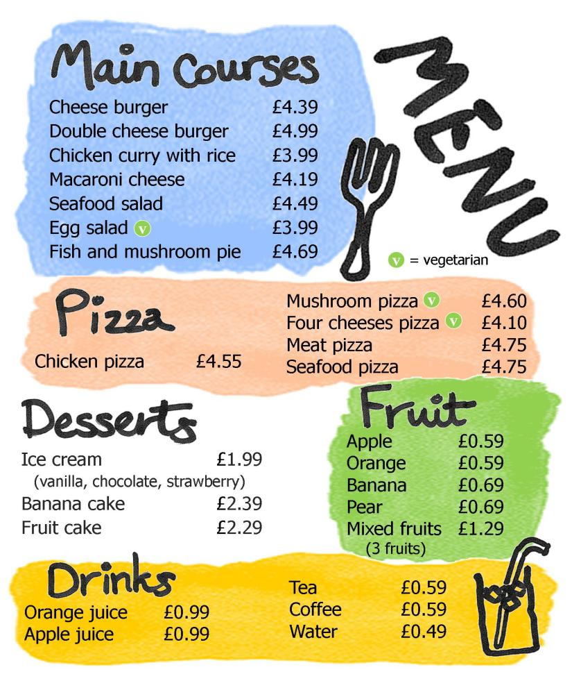

GOOD LUCK!
İbrahim SULTANOĞLU
English Language Teacher

