… EDUCATIONAL YEAR … SECONDARY SCHOOL
2nd TERM 2nd ENGLISH LISTENING EXAM FOR THE 8th GRADES

Name Surname: Class: 8 / Date:
Number: Mark: Duration: 10 min.

/ Date: 02.01.2024
Number: Mark: Duration: 10 min.

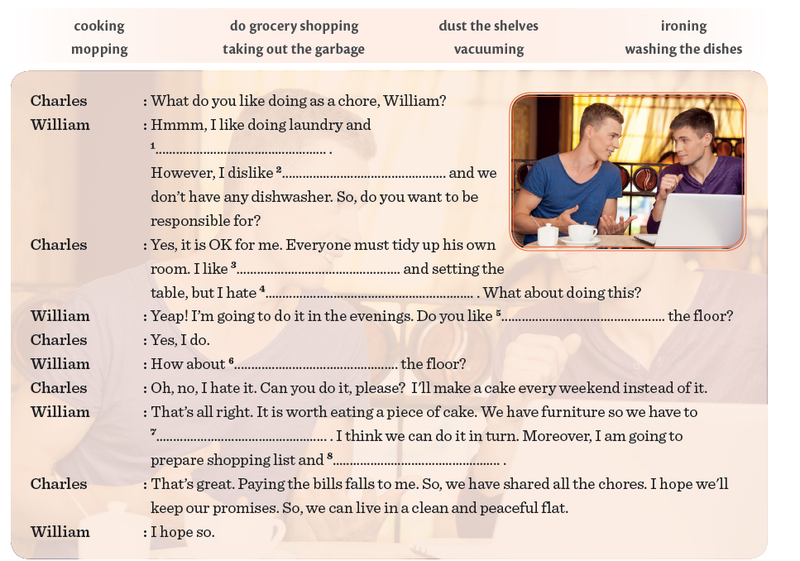
A- Listen to the recording. Fill in the blanks with the words/ phrases in the box.

