………………………. ORTAOKULU
8.
SINIF
PUAN:
. 2023-2024 EĞİTİM ÖĞRETİM YILI Adı ………………………………………………
sb
İNGİLİZCE Soyadı …………………………………………
2. DÖNEM 2. YAZILI Sınıfı …………………. No …………………. ………………
1. Soru  (10 Puan) | 2. Soru  (10 Puan) | 3. Soru  (10 Puan) | 4. Soru  (10 Puan) | 5. Soru  (10 Puan) | 6. Soru  (10 Puan) | 7. Soru  (10 Puan) | 8. Soru  (10 Puan) | 9. Soru  (10 Puan) | 10. Soru  (10 Puan) | Aldığı  Puan
………… | ………… | ………… | ………… | ………… | ………… | ………… | …….. | ------- | --------- | …….
Aşağıda verilen açık uçlu soruları cevaplayınız

S1 |  | S3
Read the text below and answer the questions.  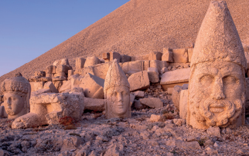  Mount Nemrut in Türkiye is famous for big statues and old ruins from about 2,000 years ago. A king named Antiochus I Theos built them. The statues show gods and leaders. They are around 8 to 10 meters tall. They’re part of a special tomb. It’s a UNESCO World Heritage Site.  a. What is Mount Nemrut famous for?  .........................................................................  b. Who built the statues and structures there?  ....................................................................... |  | Read the text and answer the question.  Here are some of his students’ comments:  Asya : In my opinion, the Internet improves our digital performances and helps us reach the information more effectively.  Hakan : Some teenagers sit in front of the screen and surf on the Net for long hours. I think this may cause some concentration and health problems.  Umut : People can do a lot of things online such as paying the bills and doing the shopping, so I think it is time-saving and more comfortable.  Gülce : Many students prefer staying at home and playing online games to going out and spending time with their real friends and so, they are getting worse at face-to-face communication.  According to the information above, which two students are talking about the positive sides of the Internet?  ........................................

S2 |  | S4
Online games are very popular among young people. Lots of children are becoming addicted to the Internet and online games. They play online games on their tablets or smartphones. These children spend 6-10 hours online and they rarely have face-to-face communication with their families. Some of them refuse to go to school because they want to stay at home and play games. Parents are not happy about their children.  A) What kind of devices can children use to play online games?  ............................................................................  B) How much time do the addicted children spend online?  ............................................................................ |  | Extreme sports are popular all over the world. People enjoy the adventure and fun. I am one of them. I like extreme sports because they are exciting. I tried paragliding before, and I enjoyed it. Then, I tried water extreme sports such as diving, kayaking, and rafting. They are all exciting, but I enjoy exploring the fish and sea animals most. I think it is more amusing than all other sports. I also take photos of different kinds of fish.  What is Martin’s favourite extreme sport?  .......................................................

S5 |  | S8
Alan Hackett is the New Zealander who made bungee jumping a popular sport worldwide. To achieve it, he jumped from the Eiffel Tower in 1987, and Alan sees that as his greatest achievement. One year later, in 1988, he designed the first bungee jumping website, and more people learned about this new exciting activity. However, Alan thinks bungee jumping is a dangerous activity, and people should take all necessary safety precautions while doing it  A) Where is Alan Hackett from?  ............................................................................  B) When did he create the bungee jumping website?  ............................................................................ |  | Tom, David, Alice, and Mary are brothers and sisters who have different responsibilities at home on different days. Here is some information about their chores:  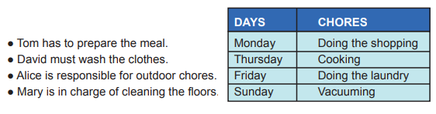  According to the information above, who has a chore at the weekend?

S6 |  | S9
Fuat Sezgin was born on 24 October 1924 in Bitlis. After he graduated from Istanbul University, he studied different languages. He knew 27 ones. He moved to Germany in 1961 and became a professor at the University of Frankfurt in 1965. Fuat Sezgin wrote scientific books and received many prizes for his studies. He died in 2018.  A) When was he born and when did he die?  B) What did he do after he finished his university education? |  | 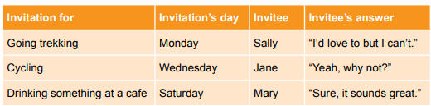  A) Which activity is at the weekend?  B) When does Alice want to ride a bike?

S7 |  | S10
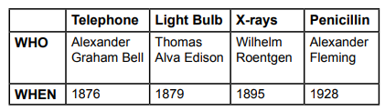  A) Thomas Alva Edison invented ..........................  B) Who invented the telephone?  ............................................................................. |  | I. Why can’t we go now?  II. Hi, Rick. Do you want to go out?  III. I must finish my homework and tidy my room first.  IV. Not now. Maybe in the afternoon.  Karışık olarak verilen cümlelerin anlamlı bir bütün oluşturacak şekilde sıralayınız.  .................................................
Not:Sınav süresi 40 dakikadır. …………………………….
Ders Öğretmeni
sorubaktarafından hazırlanmıştır Başarılar

