… EDUCATIONAL YEAR … SECONDARY SCHOOL
2nd TERM 2nd ENGLISH LISTENING EXAM FOR THE 7th GRADES

Name Surname: Class: 7 / Date:
Number: Mark: Duration: 10 min.

/ Date: 02.01.2024
Number: Mark: Duration: 10 min.

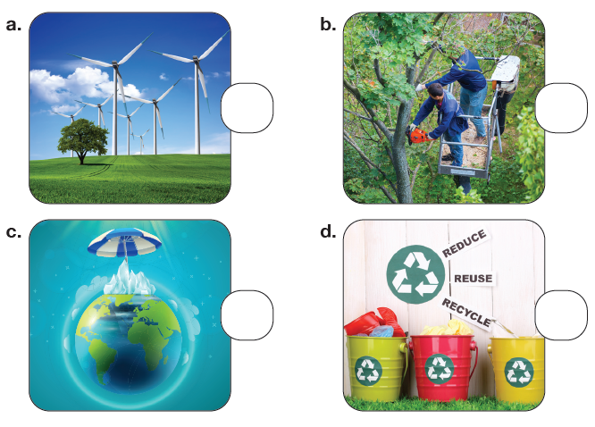
A- Listen and number the pictures.

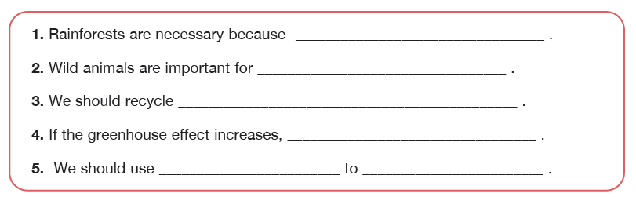
B- Listen and complete the sentences.

C- Listen and fill in the blanks.
