………………………. ORTAOKULU
7.
SINIF
PUAN:
. 2023-2024 EĞİTİM ÖĞRETİM YILI Adı ………………………………………………
sb
İNGİLİZCE Soyadı …………………………………………
2. DÖNEM 2. YAZILI Sınıfı …………………. No …………………. ………………
1. Soru  (10 Puan) | 2. Soru  (10 Puan) | 3. Soru  (10 Puan) | 4. Soru  (10 Puan) | 5. Soru  (10 Puan) | 6. Soru  (10 Puan) | 7. Soru  (10 Puan) | 8. Soru  (10 Puan) | 9. Soru  (10 Puan) | 10. Soru  (10 Puan) | Aldığı  Puan
………… | ………… | ………… | ………… | ………… | ………… | ………… | …….. | ------- | --------- | …….
Aşağıda verilen açık uçlu soruları cevaplayınız

S1 |  | S3
Nowadays, our planet Earth is in danger. Because of global warming and pollution, the Earth is dying. It is necessary to find out how to save the planet. We can do lots of things.  Here are some of them:  • Plant more trees,  • Use eco-friendly products,  • Recycle plastic, paper and glass,  • Use less water,  • Save energy,  • Reduce your waste,  • Use public transportation.  A) Why is planet Earth in danger?  B) What can we do to save the Earth?  C) Which materials can people use again? |  | Hello, I am Janet. I like watching TV in my free time. My favourite programmes are cartoons and animations. My dad prefers watching series, and he never misses new episodes of his favourite series. My mum hates watching TV, she prefers books to TV programmes. My sister, Alice loves watching documentaries and movies, but she sits in front of the TV for long hours every day, My brother prefers watching quiz shows to the news because he thinks they are more exciting.  A) Which TV programmes are Janet’s favourites?  B) Who prefers reading books to watching TV?

S2 |  |  | S4
I am Andy. I live in a big city. I love my city but some problems. Most people in my city use their private phones Cars are even a short distance away. some animal species People are losing habitat because they cut down trees.  Factories dump their waste into the river. we must take Take action and do our best to protect the environment.  Based on the given text Andy SPEAK  about .................................. |  |  | You are going to organise your dream party. Write down an invitation card and include all the following items.    - Place of the party  - Date of the party  - Type of the party  - Time of the party  - Guests
S5 |  |  |  | S8
Mrs. Keen asks her students what kind of precautions people should take about environmental problems.  Here are their answers:  Judy : People should use public transportation.  Ted : We shouldn’t use plastic bags.  Betty: People should plant more trees.  Matt : We should go everywhere using our private cars.  Who does NOT answer Mrs. Keen’s question  correctly?  ...................................... |  |  |  | Sandra takes a test about public buildings. Here are her answers:  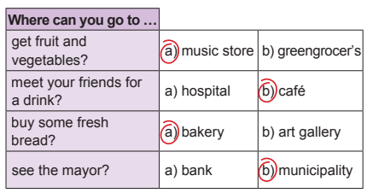  How many CORRECT answers does Sandra have?  ...............................

S6 |  | S9
Jennifer is organizing a farewell party for her best friend, Sally. She wants it to be a surprise for her. She asks her friends for some help.  Here are her friends’ answers:  Paul : Don’t worry about it. I can arrange the music.  Susan : I can prepare the guest list if you want.  David : I would like to but I’m very busy on that day. Beatrix: I think you should ask someone else.  Who will help Jennifer with the party preparations?  ............................. |  | 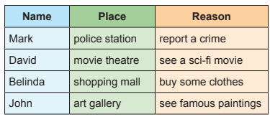  a) What kind of movies does David watch at the cinema?  ............................................................................  b) Where does Belinda go shopping to buy some clothes?  ..................................................................................

S7 |  | S10
Barbara: I will probably become a well-known professor in the future.  Gabriel : I think I will get married in my 20s and have a son and daughter.  Steve : I hope I will live in a small and peaceful village in Türkiye.  Andy : I will have a big house and an expensive sports car.  According to the information above, whose dream is about family life?  ................................. |  | Hi, Mary. Thank you for inviting me to your birthday party, but I can’t join it because I will see a doctor on Friday. Happy Birthday to you and sorry again. According to the message above,  Mary is going to go to the ....................... on Friday
Not:Sınav süresi 40 dakikadır. …………………………….
Ders Öğretmeni
Başarılar

