………………………. ORTAOKULU
7.
SINIF
PUAN:
. EĞİTİM ÖĞRETİM YILI Adı ………………………………………………
sb
İNGİLİZCE Soyadı …………………………………………
2. DÖNEM 2. YAZILI Sınıfı …………………. No …………………. ………………
1. Soru  (10 Puan) | 2. Soru  (10 Puan) | 3. Soru  (10 Puan) | 4. Soru  (10 Puan) | 5. Soru  (10 Puan) | 6. Soru  (10 Puan) | 7. Soru  (10 Puan) | 8. Soru  (10 Puan) | 9. Soru  (10 Puan) | 10. Soru  (10 Puan) | Aldığı  Puan
………… | ………… | ………… | ………… | ………… | ………… | ………… | …….. | ------- | --------- | …….
Aşağıda verilen açık uçlu soruları cevaplayınız

S1 |  | S3
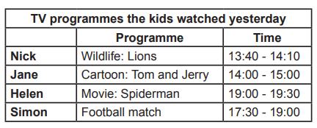  a) How long did Simon watch TV last night?  b) At what time did Simon start watching the football match? |  | Andrew : I like watching the lives of real people.  Gabriel : I like this programme because it informs people about the latest events happening in the world.  Thomas : I think it is good to know what is going on all over the world.  Kevin : I am interested in learning the secrets of space.  Who can watch the same TV programme together?

S2 |  | S4
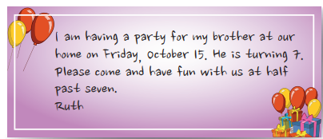  A) What is the date of the party?  B) Where is the party?  C) Who is organizing it? |  | Jane and Wilma are sitting in a cafe, and they are talking about Wilma’s sister, Angel.  Wilma : You know my sister is graduating from university next Friday.  Jane : I congratulate her on her success. Do you have any plans for her?  Wilma : I don’t know what to do. It is not easy for me to organize something.  Jane : I am good at organization. We can meet tomorrow and decide what we can do together.  Wilma : OK, thanks.  Jane : You are welcome.  A) What is the conversation about?  B) What kind of party do they want to organize?

S5 |  | S8
Your father’s birthday is next Friday. You and your  sister want to do something without his knowledge.  What do you suggest? |  | Tony : Hey, Liz! Would you like to join my graduation party?  Liz : ..................................  Tony : Then, see you in the school garden at 7 p.m. next Sunday.  Liz : OK! See you.

S6 |  | S9
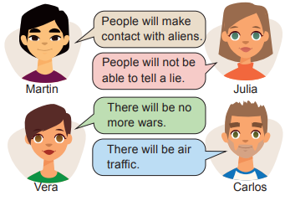  Whose dream can be about travelling?  ...................................... |  | Teacher : What must we do for our environment?  Bill : We must use solar energy.  Lucy : We must plant trees.  Lily : We must use fossil fuels as energy sources.  Eva : We must switch off the lights when we don’t use them.  Whose answer is NOT correct?  ...............................

S7 |  | S10
Mrs. Rose takes her students out to plant trees in the school garden. Then, she tells the students how to plant a tree.  I. First, get your tree and find a place to plant it.  II. Fill the hole with soil and water your tree.  III. You should not make it too deep.  IV. Place the tree in the hole carefully.  V. Then, get a shovel and dig a hole in the soil.  Which two sentences should change place to get a meaningful text?  .............and ......... |  | Barbara: I will probably become a well-known professor in the future.  Gabriel : I think I will get married in my 20s and have a son and daughter.  Steve : I hope I will live in a small and peaceful village in Türkiye.  Andy : I will have a big house and an expensive sports car.  According to the information above, whose dream is about family life?  ..............................................
Not:Sınav süresi 40 dakikadır. …………………………….
Ders Öğretmeni
Başarılar

