………………………. ORTAOKULU
6.
SINIF
PUAN:
. EĞİTİM ÖĞRETİM YILI Adı ………………………………………………
sb
İNGİLİZCE Soyadı …………………………………………
2. DÖNEM 2. YAZILI Sınıfı …………………. No …………………. ………………
1. Soru  (10 Puan) | 2. Soru  (10 Puan) | 3. Soru  (10 Puan) | 4. Soru  (10 Puan) | 5. Soru  (10 Puan) | 6. Soru  (10 Puan) | 7. Soru  (10 Puan) | 8. Soru  (10 Puan) | 9. Soru  (10 Puan) | 10. Soru  (10 Puan) | Aldığı  Puan
………… | ………… | ………… | ………… | ………… | ………… | ………… | …….. | ------- | --------- | …….
Aşağıda verilen açık uçlu soruları cevaplayınız

S1 |  | S3
Hello, I am Peter and this is my family. Last summer, we went to İzmir. My family and I stayed in a tent. My sister and I went swimming in the mornings. We played games, climbed mountains and picked flowers. My mother cooked in the evenings. My father went hiking. We sang songs and danced. It was a fantastic holiday. We had a great time  What activities did Peter and his sister do in the mornings during their holiday in İzmir?  ………………………………  Who cooked in the evenings while Peter and his family were on holiday in İzmir?  ……………………………… |  | Hasan is 28 years old. He is a technician at a high school. He gets up early and walks to work every day. He doesn’t wear a uniform. He starts work at 9 a.m. and stops at 4 p.m. He mends all the electrical devices at school. He became a technician in 2010, but he started this school in 2014. He worked at a primary school between 2010 and 2014.  What does Hasan do?  What does he do at work?

S2 |  | S4
I’m Bob. I’m a doctor at the City Hospital. I became a doctor in 2012. I’m happy to be a doctor because I can examine and help people when they are ill. I work from 8 a.m. to 5 p.m. on Monday and Tuesday. I work at night on Wednesday, Thursday, and Friday. I sometimes work at the weekend. It is a tiring job but it’s my dream job.  When did he become a doctor?  He likes his job because …………….. |  | When was Atatürk born?  .................................  When was Sabiha Gökçen born?  ..........................................
   | Occupation | Date of Birth | Place of Birth
  M.Kemal Atatürk | President | 1881 | Salonika
  Sabiha Gökçen | Pilot | 1913 | Bursa

S5 |  | S8
Abby : I had a great time in Marmaris last weekend.  Amy : ………………………………?  Abby : Sunny and warm. |  | Hi! My name is Rosie. Last summer, I went to Cappadocia, Nevşehir. It was a fantastic place. I stayed in an authentic hotel. It was full of traditional furniture. I visited fairy chimneys there. I also tried a hot-air balloon flight. It was fascinating.  A) Where did Rosie go last summer?  B) When did Rosie go there?

S6 |  | S9
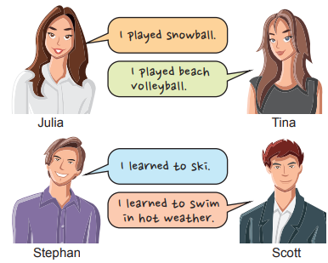  Who went on a summer holiday?  ……………………………………. |  | Mary: I am a real bookworm. I like reading all kinds of books. I went to the library with my close friend, Anna and borrowed some books. Yesterday was my birthday, and Anna bought me a novel.  A) What did she do in the library yesterday?  B) What kind of books does she like?

S7 |  | S10
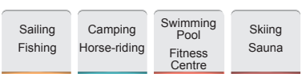  Paul and his friends are planning a vacation. they want spend time with animals and stay in a tent. What is the best choice for Paul and his friend?  ………………….. |  | Teacher : What should we do to prevent air and noise pollution?  Carl : We should cycle or walk to school.  Ivan : We shouldn’t use private cars.  Arnold : We shouldn’t throw our rubbish into the sea.  Lewis : We should use public transportation.  Who does NOT make a correct suggestion for the teacher’s question?  …………………………
Not:Sınav süresi 40 dakikadırsorubak tarafından hazırlanmıştır …………………………….
Ders Öğretmeni
Başarılar

