………………………. ORTAOKULU
5.
SINIF
PUAN:
. EĞİTİM ÖĞRETİM YILI Adı ………………………………………………
sb
İNGİLİZCE Soyadı …………………………………………
2. DÖNEM 2. YAZILI Sınıfı …………………. No …………………. ………………
1. Soru  (10 Puan) | 2. Soru  (10 Puan) | 3. Soru  (10 Puan) | 4. Soru  (10 Puan) | 5. Soru  (10 Puan) | 6. Soru  (10 Puan) | 7. Soru  (10 Puan) | 8. Soru  (10 Puan) | 9. Soru  (10 Puan) | 10. Soru  (10 Puan) | Aldığı  Puan
………… | ………… | ………… | ………… | ………… | ………… | ………… | …….. | ------- | --------- | …….
Aşağıda verilen açık uçlu soruları cevaplayınız

S1 |  | S3
Write the names of the animals.  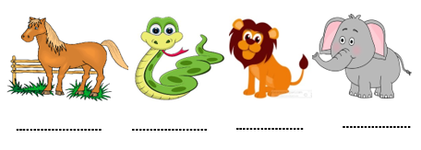 |  | 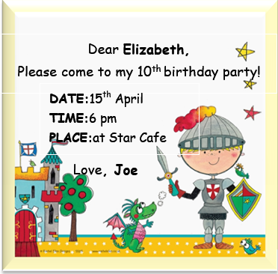  Who has theparty?  ………………………………………………..  When is theparty?  ……………………………………………………  What time is theparty?  ………………………………………………  Where is theparty?  …………………………………………………

S2 |  | S4
Aşağıdaki film türlerini yazınız.  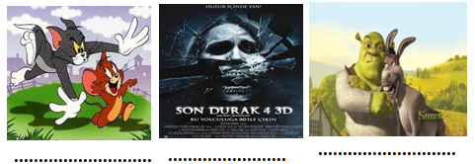 |  | Farklı olanı yuvarlak içine alın  1. Monday - September - August - March  2. science fiction - adventure - comedy - watch  3. Sunday - April - Wednesday - Friday  4. Take care - Hi! - Good bye - See you  5. cat - clown - balloon - gift

S5 |  | S8
Write the meanings of the words   |  | Sam : I’m organizing a party for  Emily. Can you help me?  Ricky : Sure. I can decorate the room.  Bob : OK, I can buy the drinks.  Mary : Of course. I can order the cake.  Judy : I can buy the gifts.  According to the conversation, who gets the presents?  ………………………………………..

S6 |  | S9
  A: .................................?  B: “Kung Fu Panda” |  | Write the diseases in the image  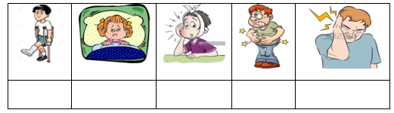

S7 |  | S10
Dylan : What’s the matter with you?  Mateo : I have a terrible toothache.  Dylan : You should .................... |  | WRITE “SHOULD” OR “SHOULDN’T”.  - We………………………….. drinkcoke.  - They ………………………….. do theirhomework.  - Ali has a runnynose, he ………………………….. take a tissue.  - Ayşe has themeasles, she ………………………….. gotoschool.  - Theclass ………………………….. stand up when their teacher comes in.
Not:Sınav süresi 40 dakikadır. …………………………….
Ders Öğretmeni
Başarılar

