........................... SECONDARY SCHOOL
5. CLASS SECOND TERM SECOND WRITTEN EXAM

A)ANSWER THE QUESTIONS
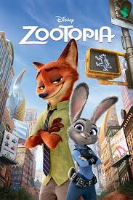  Nick Wilde and Judy Hopps  SEPTEMBER 21  14.00 - 17.00 | 1)What is the name of movie?  ......................................................................  2) Who are the characters?  ......................................................................  3) What kind of movie is it?  .....................................................................  4) When is the movie on ?  ......................................................................  5) What time is the movie?  ....................................................................

B) CHOOSE THE CORRECT ONE
1) Marry likes / doesn't like horror films. She thinks they are frightening.

2) Jurassic Park is a good film. It is very interesting / boring.

3) I like musicals / action films because I like singing.

4) The film is a horror / documantary. It is about animals in Africa.

5) I enjoy comedy films. I think they are funny/ boring

C)MATCH THE WORDS WITH PICTURES


........................... ......................... ......................... ......................... ...............................

D) WRITE THE SPORTS UNDER PICTURES
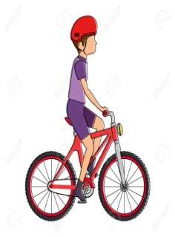
........................... ............................... ............................ ....................... ..........................

E) WRITE THE SENTENCES TO THE CORRECT CATEGORY.
1) Let's play football. 6) I'm sorry, I 'm busy.
2) That's a good idea. 7) That sounds great.
3) I'm afraid , I can't 8) How about playing hide and seek?
4) What about going to cinema? 9) Would you like to eat pizza?
5) Sure 10) No, I'm too tired.

PERMISSION | ACCEPTING | REFUSING

F) FILL IN THE BLANKS WITH CAN or CAN'T
1) We ................... put a bowl of water in front of our home for street animals.
2) Keepers ................... examine the animals.
3) We ..................... adopt animals from the animal shelter.
4) We ...................... donate money to animal shelter.
5) We ..................... feed the animals in the zoo.

G) WHAT ARE THE ANIMALS DOING?


  

