………………………. ORTAOKULU
5.
SINIF
PUAN:
. 2023-2024 EĞİTİM ÖĞRETİM YILI Adı ………………………………………………
sb
İNGİLİZCE Soyadı …………………………………………
2. DÖNEM 2. YAZILI Sınıfı …………………. No …………………. ………………
1. Soru  (10 Puan) | 2. Soru  (10 Puan) | 3. Soru  (10 Puan) | 4. Soru  (10 Puan) | 5. Soru  (10 Puan) | 6. Soru  (10 Puan) | 7. Soru  (10 Puan) | 8. Soru  (10 Puan) | 9. Soru  (10 Puan) | 10. Soru  (10 Puan) | Aldığı  Puan
………… | ………… | ………… | ………… | ………… | ………… | ………… | …….. | ------- | --------- | …….
Aşağıda verilen açık uçlu soruları cevaplayınız

S1 |  | S3
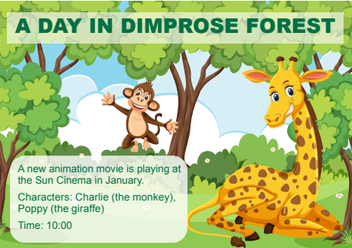  a. What is the name of the movie?  …………………………………………………………….  b. What kind of movie is it?  ……………………………………………………………. |  |   Moana  23rd November  Time: 5:30p.m  1.What’s the name of the film?  ……………………….  2.What type of film is it?  ………………………………..  3. What time does it start?  …………………………………  4.When is the film on?  …………………………………

S2 |  | S4
Read the text messages below, correct the mistakes, and rewrite the sentences  Ada: Let’s throw a welcome party in the class after school tomorrow!  Sally: I am sorry, but I should do my project work!  Lucas: Good idea! I can bring some beverages to the party.  Jack: It would be great, but I have a chess course after school. Luna Great! I am coming!  Frank: Oh, yes! Let’s do it!  a. Two friends of Ada can join the party.  …………………………………………………………………………  b. Lucas can bring food for the party.  ………………………………………………………………………… |  | Read the text and answer the questions. Chen always wakes up early on weekdays. He gets dressed and has breakfast with his parents at quarter past seven. Then, he brushes his teeth. He leaves home at half past seven. He gets back home at one o’clock and does his homework. In the evenings, he usually plays the guitar. He has a shower and goes to bed at quarter to nine.  a. Does Chen get up late on weekdays?  b. What does Chen do before he brushes his teeth?

S5 |  | S8
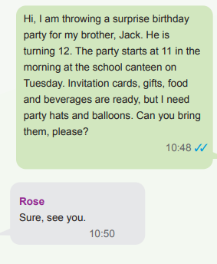  A Surprise Birthday Party for ---------------- |  | Complete sentences 11-12 according to the text below.  There are a lot of animals at the shelter. The puppies are playing with a ball, and a kitten is climbing the tree. There are some birds on the grass. They are eating some seeds. There are also two rabbits. A girl is feeding one of them. There is a vet at the shelter. He is examining the horses.  - …………………. are eating some seeds.  - The vet is ……………………………..
  Place
  Time
  Day
  Needs

S6 |  | S9
Jack and his family are on the farm today. (I) Jack is watering the vegetables. (II) His father, Mark, is cleaning the barn. (III) His mother, Melinda, is milking the sheep. (IV) His little sister, Donna, is adopting a homeless animal.  Which of the following is irrelevant to the given text?  ……………………………………. |  | Read the text below and answer the questions. Thomas feels very ill today. He has a headache and runny nose. He needs to take his pills and have a rest.  a. What is wrong with Thomas?  ………………………………………………………….  b. What should Thomas do to feel better?  ……………………………………………………….

S7 |  | S10
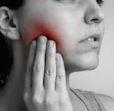  Jane is in hospital because she ................. |  | write the diseases under the pictures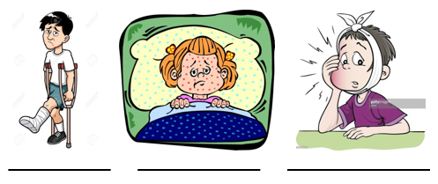
Not:Sınav süresi 40 dakikadır.sorubak tarafından hazırlanmıştır …………………………….
Ders Öğretmeni
Başarılar

