
………… EDUCATIONAL YEAR ……………. SECONDARY SCHOOL
ENGLISH LESSON 2nd TERM 2nd EXAM for 5th GRADES

Name/Surname: ……………………………………. Number:……….. Class: 5/F

A) WRITE THE NAMES OF THE ACTIVITIES UNDER THE PICTURES (10x3=30)

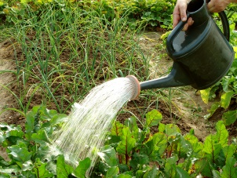
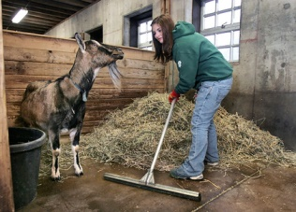




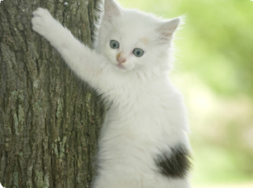


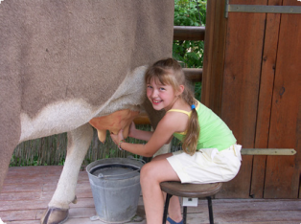
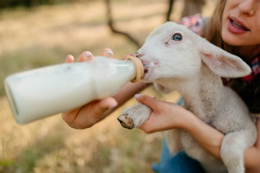
…………………………………. …………………………………. …………………………………. …………………………………. ……………………………………..

…………………………………. …………………………………. …………………………………. …………………………………. ……………………………………..

B) COMPLETE THE DIALOQUES WITH THE WORDS BELOW. ( 5x3=15 pts)

1.Ekrem:: Mummy, Can I adopt a cat?

Mom : Of ……………….. , you can.

2.Berk: Dad,can we …………………………… some money for the shelter ?
Dad : Yes, that’s a good ……………

3.Seçil : “Sshh! Be quiet. The kittens are ……………”
4.Nazlı: What are you doing Sude?
Sude : I am ……………. my dog now. It is very hungry.

C) UYGUN CEVAPLAR YAZINIZ (5x4=20 pts)


1. Let’s go to cycling together. A. _____________________________________ .
- Shall we play basketboll today? B _____________________________________ .
- How about jogging in the park? C. _____________________________________ .
- Shall we go dancing after school? D. _____________________________________ .
- Why don’t we go camping this weekend? E. _____________________________________ .

D) WRITE THE CORRECT WORDS UNDER THE PICTURES (8x3=24 pts










E) FILL IN THE BLANKS WITH “must/mustn’t ” (5x3=15 pts)

- It’s my friend’s birthday next Saturday. What must you do?
- What must you do after party?
- The food isn’t healthy. What mustn’t you do?

- You have party on Sunday. What must you do?

