………………………. ORTAOKULU
7.
SINIF
PUAN:
. … EĞİTİM ÖĞRETİM YILI Adı ………………………………………………
sb
İNGİLİZCE Soyadı …………………………………………
2. DÖNEM 1. YAZILI Sınıfı …………………. No …………………. ………………
1. Soru  (10 Puan) | 2. Soru  (10 Puan) | 3. Soru  (10 Puan) | 4. Soru  (10 Puan) | 5. Soru  (10 Puan) | 6. Soru  (10 Puan) | 7. Soru  (10 Puan) | 8. Soru  (10 Puan) | 9. Soru  (10 Puan) | 10. Soru  (10 Puan) | Aldığı  Puan
………… | ………… | ………… | ………… | ………… | ………… | ………… | …….. | ------- | --------- | …….
Aşağıda verilen açık uçlu soruları cevaplayınız

S1 |  | S3
Read the Read the text and answer the questions below.( Metni okuyup soruları metne göre yanıtlayınız.)  Hi, my name is Eren. I'm twelve years old. I have many dreams and hopes for my future. I always dream of being a famous football player in the future. I hope one day I will play at Fenerbahçe team. I believe I will score a lot of goals and win lots of medals in my career. I will have a successful life. Also, I'll earn a lot of money. So, I'll help my family and poor people in my country. I want to get married in the future and I will have two children. I don’t like big cities so I will live in a small city in the future. I also like animals. I will have a dog. I believe all these hopes are not just a dream and one day they will come true.  ❖ Which football team does Eren hope to play for in the future?  ………………………………………………….  ❖ What kind of city does Eren prefer to live in?  …………………………………………………… |  | 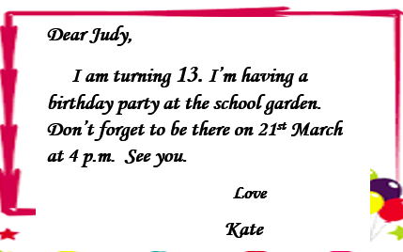  ❖ Where is the party?  …………….………………………………………  ❖ What time is the party?  …………….………………………………………

S2 |  | S4
"My name is Ceyda. I have four pets – a dog, two kittens and a parrot. I really enjoy looking after them. I hope I’ll be a vet one day. Also I will be animal protector and I will provide animals a better life."  a) What is her name?  ……………………………………………………………………  b) How many pets does she have?  …………………………………………………………………… |  | Complete the sentences with “ Simple Past Tense, Simple Present Tense, Future Tense ”.  1 . Robert …………. a football match last night. (watch)  2 . It ………. probably …………….. tomorrow. (rain)

S5 |  | S8
Arda: …………….. is the party?  Mehmet: Next Friday.  Arda: I’m sorry but I have an exam on that day. |  | Hi! My name’s Kadir. I always dream of being a famous football player. I will play for my favorite team, Galatasaray. I believe I will score a lot of goals and win lots of medals in my career. Also, I’ll earn a lot of money. So, I’ll help my family and poor people in my country. I hope these will come true.  The text is about Kadir’s ……

S6 |  | S9
Fill in the blanks with ” a / an / some / any.”  1.There are ……some………..…..candles.  2.There is ……some……………beverages.  3.Are there ……any…………..party hats?  4. There isn’t ……any………………..tea.  5. There aren’t ……any……………guests. |  | Tony :............is your favourite TV programme?  Jack : It is a quiz show.

S7 |  | S10
  When do we celebrate the Mother´s day?  ……………………………………………… |  | Prepare an invitation card four your party. Decide your party type, time, place, date,etc.
Not:Sınav süresi 40 dakikadır. …………………………….
sorubak.com tarafından hazırlanmıştır Ders Öğretmeni
Başarılar

