………………………. ORTAOKULU
7.
SINIF
PUAN:
. 2023-2024 EĞİTİM ÖĞRETİM YILI Adı ………………………………………………
sb
İNGİLİZCE Soyadı …………………………………………
2. DÖNEM 1. YAZILI Sınıfı …………………. No …………………. ………………
1. Soru  (10 Puan) | 2. Soru  (10 Puan) | 3. Soru  (10 Puan) | 4. Soru  (10 Puan) | 5. Soru  (10 Puan) | 6. Soru  (10 Puan) | 7. Soru  (10 Puan) | 8. Soru  (10 Puan) | 9. Soru  (10 Puan) | 10. Soru  (10 Puan) | Aldığı  Puan
………… | ………… | ………… | ………… | ………… | ………… | ………… | …….. | ------- | --------- | …….
Aşağıda verilen açık uçlu soruları cevaplayınız

S1 |  | S3
Read the Read the text and answer the questions below.( Metni okuyup soruları metne göre yanıtlayınız.)  Hi, Mike.I’m going out to buy a present for Alice.Please Help me wşth the arrangements.First, prepare some snacks.We need some beveragesBuy some cold drinks from the market.Don’t forget to take the cake from the patisserie.The party will be crowded so we need a lot of plates and glasses.Finally take everything to the Rainbow Cafe and check the decorations.The party starts at 14.30 so please get ready until 14.00.Thanks for your help.  Whose party is it?  …………………………………………………………………….  Where is the party?  ……………………………………………………………………. |  | 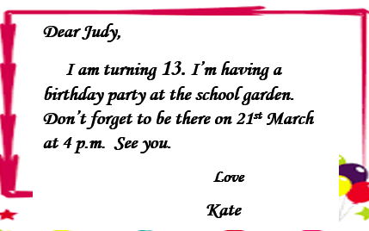  1. What kind of a party is it?  …………………………………………  2. When is the party?  …………………………………

S2 |  | S4
Fill in the blanks with “ why don’t you, let’s, how/what about, shall we, should”  1.A:.......... throw a fancy dress party this weeked.B: That’s a good idea.  2. A: ...........arranging the music?  3. ............... invite all our friends?  4. ........ buy the birthday cake?  5. We ......... buy some sandwiches and cookies. |  | Fill in the blanks with “a lot of, much, many”  1.There are ..............beverages .Don’t buy ....................  2. I didn’t invite ................. people for the party.  3.Did you prepare ................. cookies ?  4.Please help me with the arrangements. I don’t have .............. time.

S5 |  | S8
Arda: …………….. is the party?  Mehmet: Next Friday.  Arda: I’m sorry but I have an exam on that day. |  | Hi! My name’s Kadir. I always dream of being a famous football player. I will play for my favorite team, Galatasaray. I believe I will score a lot of goals and win lots of medals in my career. Also, I’ll earn a lot of money. So, I’ll help my family and poor people in my country. I hope these will come true.  The text is about Kadir’s ……

S6 |  | S9
Fill in the blanks with ” a / an / some / any.”  Would you like...............tea?  Do you need ...................... help?  She wants to buy ........................ big house.  If you want to make orange juice,take .............. orange and,etc.  We need .............. decorations for the party. |  | Tony :............is your favourite TV programme?  Jack : It is a quiz show.

S7 |  | S10
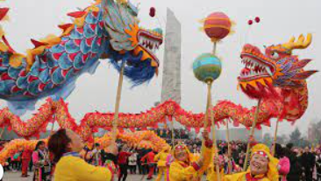  What celebration is this?  ……………………………………………………….. |  | Prepare an invitation card four your party. Decide your party type, time, place, date,etc.
Not:Sınav süresi 40 dakikadır. sorubak.com tarafından hazırlanmıştır …………………………….
Ders Öğretmeni
Başarılar

