Ortaokulu ……………….. Eğitim-Öğretim Yılı 7.Sınıf İngilizce Dersi
2.Dönem 1.Yazılı Sınavı

Adı - Soyadı: Sınıfı / No: NOTU:

A. PROGRAM ADLARINI RESMİN ALTINA YAZINIZ. ( 2 x 8 = 16 )

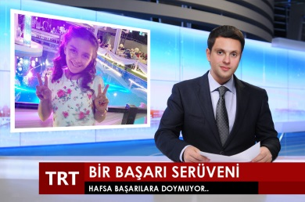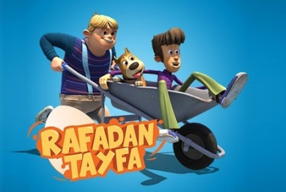

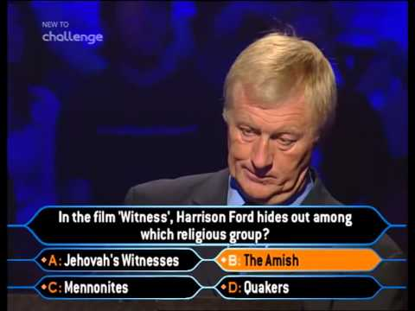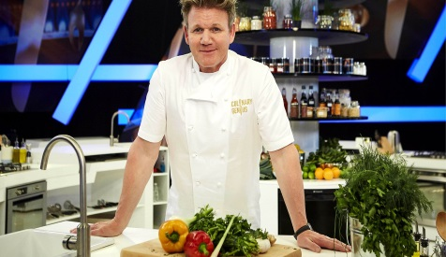

B. BOŞLUKLARI UYGUN ŞEKİLDE DOLDURUNUZ ( 4 x 5 = 20 )
1 . Robert …………………. a football match last night.
2 . It …………………. probably …………….. tomorrow
3 . Tiffany …………………. the house yesterday.
4. I usually …………………. a quiz show once a week.
5 . In the future, I …………………. in a big city. I want to live in a small city.

C. KELİMELERİ TAMAMLAYINIZ ( 2 x 7 = 14 )

1 . …………………… funny clothes 2 . …………………… invitation card

3. …………………… candles 4 . …………………… relatives
5 . …………………… a traditional meal 6 . …………………… a birthday party
7 . …………………… guests

D. AŞAĞIDAKİ TABLOYA UYGUN İFADELERİ YAZINIZ. ( 2 x 15 = 30 )

Offering / Suggesting

Accepting Refusing

E. SPRULARI CEVAPLAYINIZ ( 4 x 5 = 20 )
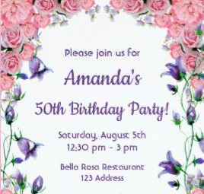
1.What type of a party is it?
……………………………………….
2.Who is organising it?
……………………………………….
3.Where is it?
……………………………………….
4.What is the date of the party?
……………………………………….
5. What time does it start?
……………………………………….
Peter

https://www.ingilizceciyiz.com/

