………………………. ORTAOKULU
6.
SINIF
PUAN:
. 2023-2024 EĞİTİM ÖĞRETİM YILI Adı ………………………………………………
sb
İNGİLİZCE Soyadı …………………………………………
2. DÖNEM 1. YAZILI Sınıfı …………………. No …………………. ………………
1. Soru  (10 Puan) | 2. Soru  (10 Puan) | 3. Soru  (10 Puan) | 4. Soru  (10 Puan) | 5. Soru  (10 Puan) | 6. Soru  (10 Puan) | 7. Soru  (10 Puan) | 8. Soru  (10 Puan) | 9. Soru  (10 Puan) | 10. Soru  (10 Puan) | Aldığı  Puan
………… | ………… | ………… | ………… | ………… | ………… | ………… | …….. | ------- | --------- | …….
Aşağıda verilen açık uçlu soruları cevaplayınız

S1 |  | S3
Hello, I am Peter and this is my family. Last summer, we went to İzmir. My family and I stayed in a tent. My sister and I went swimming in the mornings. We played games, climbed mountains and picked flowers. My mother cooked in the evenings. My father went hiking. We sang songs and danced. It was a fantastic holiday. We had a great time  What activities did Peter and his sister do in the mornings during their holiday in İzmir?  ………………………………  Who cooked in the evenings while Peter and his family were on holiday in İzmir?  ……………………………… |  | 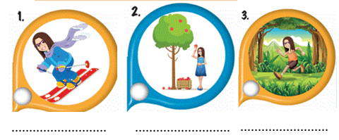

S2 |  | S4
Verilen tarihlerin okunuşlarını örnektekine bakarak yazınız.  e.g. 3 March 1987: The third of March, nineteen eighty seven.  1) 7 July, 1984: _______________________________  2) 21 January, 2008: ________________________________  3) 13 May, 1864: ___________________________________  4) 20 February, 2019: __________________________________  5) 28 August 1583: __________________________________ |  | When was Atatürk born?  .................................  What was Sabiha Gökçen's occupation?  .....................  When was Sabiha Gökçen born?  ..........................................
   | Occupation | Date of Birth | Place of Birth
  M.Kemal Atatürk | President | 1881 | Salonika
  Sabiha Gökçen | Pilot | 1913 | Bursa

S5 |  | S8
Aşağıdaki resimlerde yer alan meslekleri yazınız.  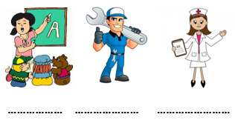 |  | Boşlukları “am/is/are/was/were” ile doldurun.  She felt sad yesterday, but she ………… very happy today.  My friends …………. with me two hours ago.  There ……………. a good film on TV last night.  Q: Where ……….. you at two o'clock yesterday? A: I ……….. at the office.  Last year my grandma and grandpa ……….. 76 years old.

S6 |  | S9
Verilen kelimelerin Türkçe karşılıklarını yazın.  bagel: ………………..  downtown: ………………..  manager: ………………..  run errand: ………………..  sunny: ………………..  seaside: ………………..  junk food: ………………..  anxious: ………………..  village: ………………..  ticket: ……………….. |  | A: I work at a hospital  I am not a…………………

S7 |  | S10
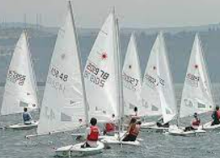  Resimdeki tatil aktivitesi nedir? |  | Açıklamaları verilen meslekleri noktalı yerlere yazınız.  a) Helps doctors and works in ahospital……………….  b) Works in a Office and answers the phone…………………  c) Teaches lesson fort he student …………………  d) Drives a taxi …………………  e) Works in an airport …………………
Not:Sınav süresi 40 dakikadır. sorubakcom tarafından hazırlanmıştır …………………………….
Ders Öğretmeni
Başarılar

