………………………. ORTAOKULU
6.
SINIF
PUAN:
. 2023-2024 EĞİTİM ÖĞRETİM YILI Adı ………………………………………………
sb
İNGİLİZCE Soyadı …………………………………………
2. DÖNEM 1. YAZILI Sınıfı …………………. No …………………. ………………
1. Soru  (10 Puan) | 2. Soru  (10 Puan) | 3. Soru  (10 Puan) | 4. Soru  (10 Puan) | 5. Soru  (10 Puan) | 6. Soru  (10 Puan) | 7. Soru  (10 Puan) | 8. Soru  (10 Puan) | 9. Soru  (10 Puan) | 10. Soru  (10 Puan) | Aldığı  Puan
………… | ………… | ………… | ………… | ………… | ………… | ………… | …….. | ------- | --------- | …….
Aşağıda verilen açık uçlu soruları cevaplayınız

S1 |  | S3
Read the paragraph below and answer the questions that follow:  "The Johnson family decided to visit the Grand Canyon during their summer vacation. They explored various trails, took dozens of photos of the breathtaking views, and even attended a ranger-led educational program about the park's history and wildlife."  What did the Johnson family do during their summer vacation?  …………………………………..  Name two activities the Johnson family enjoyed at the Grand Canyon.  ………………………………. |  | Aşağıdaki aktiviteleri görsellerin altına yazınız.  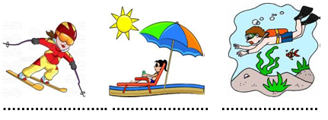

S2 |  | S4
Write the pronunciations of the given dates, following the example provided:  e.g. 4 April 1992: The fourth of April, nineteen ninety-two.  12 December, 1975: _______________________________  9 November, 1999: ________________________________  15 March, 1824: ___________________________________  22 October, 2005: _________________________________  31 January 1602: __________________________________ |  | Hi everybody! My name is Gezgin. Last summer I went to Antalya. I tried sailing and swimming there. It was very exciting. I went camping with my friends and we stayed in a tent in the forest but I think it was boring. I like water sports more. Also, I learned rafting. It was dangerous but it was very enjoyable. I went to Erzurum two months ago. It was very cold. I tried skiing there with my uncle. I think it is difficult but amusing. You should tryit.  Where was Gezgin last summer?  ……………………………..  What did he try in Antalya?  …………………..

S5 |  | S8
Aşağıdaki resimlerde yer alan meslekleri yazınız.  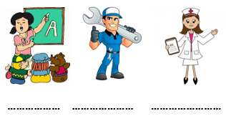 |  | Put the words in the correct order.  1-can /Atechnician / electrical devices / repair  …………………………………………………………  2- to different places / A driver / drive people / can  ………………………………………………  3-write /A secretary / can / letters and e-mails  …………………………………………………  4-cars / can /A mechanic / mend  ……………………………………………………  5-teach new things / at school /A teacher / can / to students  …………………………………………

S6 |  | S9
Verilen kelimelerin Türkçe karşılıklarını yazın.  bagel: ………………..  downtown: ………………..  manager: ………………..  run errand: ………………..  sunny: ………………..  seaside: ………………..  junk food: ………………..  anxious: ………………..  village: ………………..  ticket: ……………….. |  | Complete thetextwith “in, at, on”  My father’s name is Jack. He is a mathsteacher. He usuallygetsup ………. 6.30  ………….TuesdaysandThursdays he has lunch in theschool …………12.30, because he has lessons. ……….. theweekend he getsuplater. My father has his summerholiday  ………….August. He has a difficultjob, but he loves i

S7 |  | S10
A:………. is the fun fair?  B: It is in May  ………………… |  | Açıklamaları verilen meslekleri noktalı yerlere yazınız.  Writes news on newspaper .............  Acts for movie or theatre.............  Sells the meat.............  Cuts and sews the dresses.............  Pulls out the teeth.............
Not:Sınav süresi 40 dakikadır. sorubak.com tarafından hazırlanmıştır …………………………….
Ders Öğretmeni
Başarılar

