………………………. ORTAOKULU
5.
SINIF
PUAN:
. 2023-2024 EĞİTİM ÖĞRETİM YILI Adı ………………………………………………
sb
İNGİLİZCE Soyadı …………………………………………
2. DÖNEM 1. YAZILI Sınıfı …………………. No …………………. ………………
1. Soru  (10 Puan) | 2. Soru  (10 Puan) | 3. Soru  (10 Puan) | 4. Soru  (10 Puan) | 5. Soru  (10 Puan) | 6. Soru  (10 Puan) | 7. Soru  (10 Puan) | 8. Soru  (10 Puan) | 9. Soru  (10 Puan) | 10. Soru  (10 Puan) | Aldığı  Puan
………… | ………… | ………… | ………… | ………… | ………… | ………… | …….. | ------- | --------- | …….
Aşağıda verilen açık uçlu soruları cevaplayınız

S1 |  | S3
Match the pictures with movie types  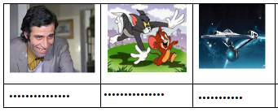 |  |   Moana  23rd November  Time: 5:30p.m  1.What’s the name of the film?  ……………………….  2.What type of film is it?  ………………………………..  3. What time does it start?  …………………………………  4.When is the film on?  …………………………………

S2 |  | S4
What type of movies do you like?  ……………………………………………………  What's your favourite movie?  …………………………………………………… |  | write the diseases under the pictures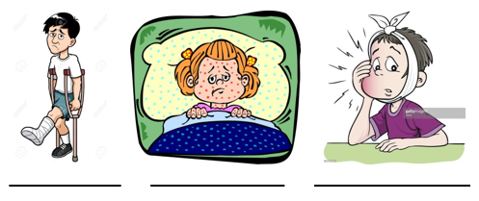

S5 |  | S8
The months of the year  1. January 7. July  2. ................... 8. ...................  3. March 9. September  4. ................... 10. ...................  5. May 11. November  6. ................... 12. ................... |  | 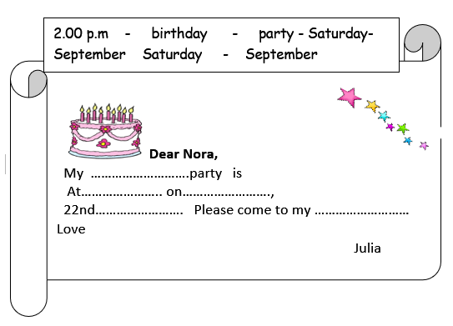  Fill in the blanks in the invitation card with the words in the box

S6 |  | S9
Write the Turkish meanings  exciting : ................  strong : ..................  What is the movie about ? : ................................  Cartoon :...........................  interesting : ........................... |  | Wilma : Hello, Robert. I have a birthday party. Do you want to join it?  Robert : Really! When is your birthday?  Wilma : It’s on the thirteenth of March.  Robert : OK, see you at the party  When is Wilma's birthday?

S7 |  | S10
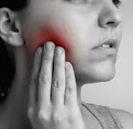  Jane is in hospital because she ................. |  | Place : Our house  Date : Sunday, March 11  Time : 15:00  What time does the party start?
Not:Sınav süresi 40 dakikadır. sorubak.com tarafından hazırlanmıştır
Ders Öğretmeni
Başarılar

