5. SINIF İNGİLİZCE 2. DÖNEM 1. DİNLEME SINAVI

A- Listen and tick the objects Satoshi needs for the party.
DİNLEYİN VE SATOSHI NIN İHTİYAÇLARINI İŞARETLEYİN

CEVAPLAR

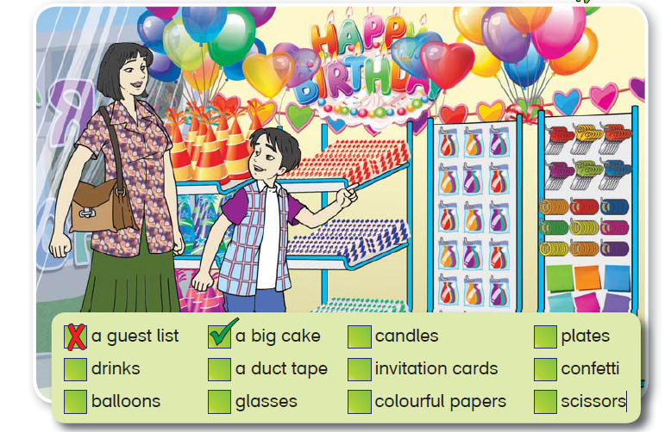
BIG CAKE, CANDLES, DRINKS, DUCT TAPE, CONFETTI, BALLOONS, COLORFUL PAPERS, SCISSORS

