2023-2024 ACADEMIC YEAR ŞEHİT ALİ YILDIRIM ANATOLIAN HIGH SCHOOL
FIRST TERM FIRST WRITTEN ENGLISH EXAM OF 12TH GRADES
Name:
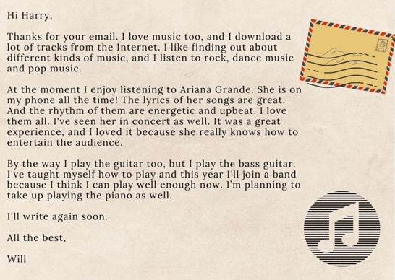
1.E12.1.R1.Read the postcard and answer the questions.
a. What kind of music does Will listen to?
………………………………………………………
b. Who is his favourite singer?
…………………………………………………………
c. Will he join a music group?
…………………………………………………………

d. Can he play the piano?
…………………………………………………………
2.E12.1.R1. Read the text and answer the questions.
Ashley : Hey, I’ll tell you what, have you heard of the concert at the City Park?
Kathleen : When?
Ashley : Tomorrow, at eight. I’m going alone. What about joining me and seeing the band play?
Kathleen : I’m done with my assignment so I can go with you.
Ashley : Shall we eat dinner together at seven and then go to the concert?
Kathleen : It sounds great.

1.What time is the concert? 1.…………………………………………….

2.What are the girls going to do before the concert? 2. .…………………………………………….

3.E12.1.R2. Answer the questions according to the table.
Table: Music Preferences of High School Students.
JAZZ | %10
BLUES | %55
FOLK | %10
POP | %25
1.What kind of music is the most popular one?
.…………………………………………………
2.Which two kinds of music are equally popular?
...…………………………..……………………

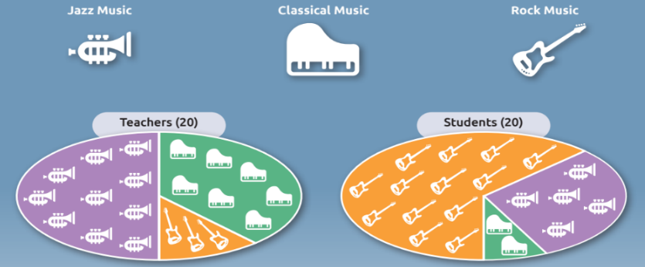
4.E12.1.R2. Look at the survey which was given to 20 teachers and 20 students and answer the questions.
- Which type of music is the most preferred one among the teachers?
….......................................................................

- Which one is more popular among the students, jazz music or classical music?
……………………………………………………

5.E12.1.W1.The table below shows music preferences of 100 students.Write down two sentences to compare.
Music Preferences of the Students
Types of Music | Number of the Students
POP | 27
ROCK | 39
CLASSICAL | 34
1……………………...…………………………………
2……………………...…………………………………

6.E12.R1. Write down the irrelevant sentence to the text and explain the reason.

(1)My friend, Tom always backs me up and supports my decisions.(2) He is very jealous. (3)He has a lot of friends and he loves helping them. (4)He gets on well with old people. (5) He makes me happy.
The irrelevant sentence is because……………………………………………
7.E12.2.R1. Write down the irrelevant sentence to the text and explain the reason.

(1)My sister’s name is Maria. (2)She is 23 years old. (3)She is tall and Brown hair. (4)She goes to her office by bus. (5) She is very beautiful with her big green eye.
The irrelevant sentence is because……………………………………………
8.E12.2.R1. Write down the irrelevant sentence to the text and explain the reason.

(1)Ersin is the most honest person I have ever seen. (2) He tells always the truth. (3) He is also very stingy.
(4) I trust him very much. (5) Unlike others he never deveives me.

The irrelevant sentence is because……………………………………………

9.E12.2.R2 Answer the questions according to the conversation

Mustafa: I think a good friend must support me even if I make mistakes
Miraç: I don’t agree with you. A good friend must tell you your mistakes.
Ersin: In my opinion, true friendship is impossible nowadays so I don’t trust anyone.

1.Who believes that true friendship is hard to find? 1.………………………….....................................

2.What do they talk about in this dialogue? 2…………………..................................................

10.E12.2.R2 Answer the questions according to the conversation

Marry: I think ta goog friend is someone who can understand how you feel. And will be tolerant if there’s something wrong.
George:I don’t think so. A good friend must tell you your mistakes. Also he must be realistic.
Jack:In my opinion, true friendship is impossible in this virtual world.

1.Who believes that true friend must be understanding? 1.………………………….....................................

2.What is the conversation about? 2.………………………….....................................
GOOD LUCK!
ESMA DİLEK DEMİR

