2023-2024 ACADEMIC YEAR ERTUGRULGAZI HIGH SCHOOL READING & WRITING PRACTICE EXAM FOR 12TH GRADES
Student’s name:
Class&Number:

Reading A (15) | Reading B (15) | Reading C (20) | Reading D (20) | Reading E (20) | Writing F (10) | Total (100)
READING PART

E12.1.R1. Students will be able to infer people’s music preferences from their ideas about music in a reading text.
- Read the text below and give correct answers to the questions (15p)

Ryan: It's going to be a great trip. I really can't wait!
Dad: Me neither. Have you packed your suitcase, Ryan? You know, we are hitting the road before the sunrise.
Ryan: Already, Dad. A long drive, isn't it?
Dad: Yeah, about seven hours.
Ryan: Why don't we decide on the music list then? For the drive, I mean.
Mom: That's a good idea. If you ask me, jazz will be nice. I love it, you know. The tunes are relaxing.
Ryan: Jazz? Come on! No way, Mom. It's dull. I like rock more than jazz. The drums, electric instruments, all make you feel energetic. We need energy for the journey.
Dad: Mmm, I like jazz, but I'm not a big fan of rock. It's raucous.
Mom: That's so true. How about blues or country?
Dad: I'd rather listen to country than blues. Both have song lyrics with similar themes, but they differ in rhythm, harmony, and instrumentation.
Ryan: I'm afraid we can't reach an agreement this way, can we?
Mom: I tend to agree with you at this point, Ryan. We all have different music choices. One's meat is another's poison.
Dad: That's right. Then, we should listen to the radio. Whatever comes should be OK. We'll see the lucky one. Any objections?
Ryan: Deal, dad.
Mom: Now that we have figured things out, it’s dessert time.

- How many hours will the drive take?..................................................................................
- Who prefers jazz music?......................................................................................................
- What does Ryan think about rock music?............................................................................
- Are their music preferences the same?................................................................................
- What will they listen on the way?........................................................................................

- Read the expressions which were written in the text and write OPINION, AGREEING or DISAGREEING (15p)

That’s a good idea: ………………………………………………………..
If you ask me, Jazz will be nice: ………………………………………
No way, mom:………………………………………………………………..
I’m afraid we can’t reach an agreement:………………………..
I tend to agree with you at this point, Ryan:……………………

E12.1.R2. Students will be able to analyze surveys/interviews to answer related questions.
E12.1.W1 Students will be able to write a survey report on their friends’/teachers’ music preferences

- Look at the survey which was given to 20 teachers and 20 students and answer the questions (20p)
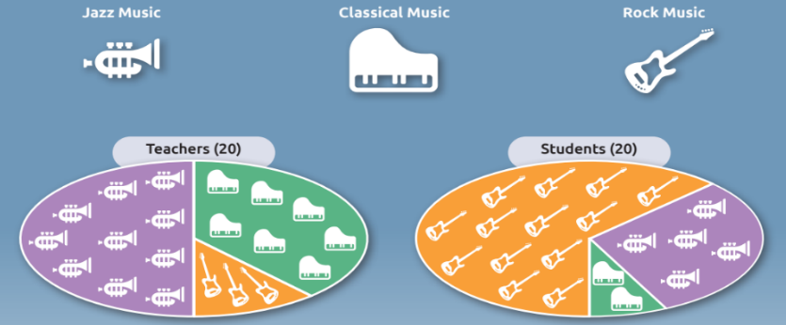

- Which type of music is the most preferred one among the teachers?.......................................
- Which type of music is not preferred much according to the teachers?....................................
- What do the students think about rock music?..........................................................................
- Which one is more popular among the students, jazz music or classical music?.......................

E12.2.R1. Students will be able to find irrelevant content about the descriptions of the people in a text. (20p)

- Look at the sentences below and write if they are RELEVANT or IRRELEVANT

- My friend always backs me up and supports my decisions.S/he is very generous: ……….
- I have a lot of friends and I love helping them. I can say I am helpful…………………………..
- Tom gets on well with old people, they love him because he is respectful……………………
- Carol does not like smiling. She always seems supportive…………………………………………….

E12.2.R2 Students will be able to identify the main conclusions in argumentative texts

- Answer the questions according to the conversation

Tina: I think a good friend must support me even if I make mistakes
Carol: I don’t agree with you. A good friend doesn’t have to be tolerant every time. S/he must tell you your mistakes.
Jack: In my opinion, true friendship is impossible in this technological world. We all have virtual friends.

- Who believes that true friendship is hard to find?...................................
- What do they talk about in this dialogue?..................................................

E12.2.W.1 Students will be able to write an opinion essay about qualities of a good friend by stating results.

- What are the qualities of a good friend according to you? Write at least five sentences. (10 p)

