QUIZ 5 GRADE UNIT 7 ( PARTY TIME)

A) Answer the questions
1.) How many months are there in a year?
2.) How many days are there in a week?
3.)What are winter months?
4.) What is your favourite season?Why?
5.)Which season is hot and sunny?
6.) When is your birthday?

B) Ask questions
1.) ...........................................................................?
There are four seasons in a year.
2.) ................................................................................?
My birthday is on 17 March.
3.)..................................................................................?
My favourite season is spring because the weather is warm and I like smelling flowers.
4.)...................................................................?
They are June, July, August
C) Write seasons and months
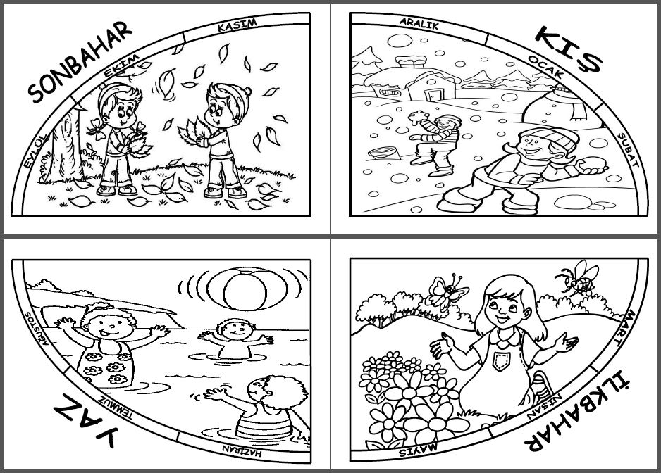
________ __________ ___________ __________

D) Write the words' TURKISH meanings
throw a party :
decorate the room:
send an invitation card:
buy gift:
invite :
beverages:
candle:
bake a cake:
fancy dress party:
join a paty:
prepare the guest list:

E) VERİLEN DAVETİYEYE GÖRE SORULARI CEVAPLAYIN
Dear Selin,
Can you come to my ___________________ party this weekend, please? It is at two o’clock on Saturday in my house. Don’t forget to wear your costume.
Love Arnold,
Place :
Time :
Date:
1.What kind of party is this? .__________________________ 2.What time is the party? __________________________ 3.Where is the party? __________________________ 4.What is the date of costume party? ______________________________

F) Write sentences using "must" "mustn't"
1.) You _ _ _ _ _ be late for school.
2.) You _ _ _ _ _ go to the dentist with a toothache. 3.) It’s raining. You _ _ _ _ _ take your umbrella.
4.) You _ _ _ _ _ _ eat chocolate and candy a lot. It is bad for your teeth.

G) Choose the correct one
1- Hangisi yanlış eşleştirilmiştir?

  - 
A) birthday cake B) gift C) drinks D) beverages

2.) “What is your favourite exercise?”
Yukarıda ki soruya uygun düşen cevabı seçin.
a) I can do jogging.
b) She likes swimming.
c) I like rafting but I don’t like running.
d) My favourite exercise is yoga

3.) A: ………………………………………………
B: That sounds great.
Boşluğa uygun düşen ifadeyi seçin.
a) Do you want to go rollerskating?
b) I can’t do rollerskating.
c) I don’t like rollerskating.
d) Do you like rollerskating?

4.) Your friend has two tickets for Spidermen film at the cinema. He invites you to the film and you accept his offer.

a) I am sorry I can't because I have to study.
b) That's not a good idea.
c) No, I can't because I have to clean my room.
d) That is a good idea. I am bored at home.


5-) Their favourite activity is ______ in the park.
a) diving
b) jogging
c) hiking
d)climbing

6-) Diyalogta boslugu tamamlayan seceneği bul
AYLİN:…………………………………… ?
SELİN: It is in August.
a) What’s your favourite season?
b) When is your birthday?
c) What’s your name?
d) What time is the party?

7-) Your friend has got a birthday party at five o'clock on Saturday. He invites you to his party. You want to join the party. You ask permission from your father.
a) Would you likle to join my party, dad?
b) Do you want to come to my party, dad?
c) Can I go to my friend's party on Saturday, dad?
d) Where would you like to come, dad?

8) A: Would you like to join fancy dress party?
B: ....................., because I have another appointment.

a) Sure b) That's a good idea.
c) That sounds great. d) I am sorry, I can't.

9.) We celebrate my mother’s party is ……..half past four…….. Saturday.

a)at /on b) at / in c)in / on d)on / in

10.) There are …………. days in a year.

a)12 b) 365 c) 4 d)30

H) Boşluğa uygun düşen kelimeyi yazın

1.)Ahmet: My friends invite me his brthday party for tomorrow. I must buy ……………………. for him. What shoul I buy?
Samet: You cany buy PC game DVD. He llikes playing PC games.

2.) Don’t forget to send ……………………….. cards.
3.) This is her thirteenth birthday so there are 13 ……………… on the birhday cake.

