A) Sıra sayılarının sonlarını yazın. -st -th -nd -rd ile tamamlayın.
10__ 15__ 6__ 2__ 21__ 9__ 1__ 3__ 23__ 30__ 31__ 25__ 4__ 5__ 11__ 22__
B) Dört mevsimi yazın.
Yaz:____________ Kış:____________ İlkbahar:_____________ Sonbahar:_______________
C) Ayları doğru sırayla yazın.
March - November - February - June - January - October - December - April - July - May - September - August
1._____________ 2.______________ 3.______________ 4.______________ 5.______________ 6.______________
7._____________ 8.______________ 9.______________ 10.______________ 11.______________ 12.______________
D) Soruları verilen bilgilere göre cevaplayın.
Birthdays: Deniz: 18.05.2004 Recep:21.07.2004 Berkay:02.03.2004 Kübra:25.10.2004 Yağmur:03.12.2004
1. When is Deniz's birthday? : It is _________________________________
2. When is Recep's birthday? : It is _________________________________
3. When is Berkay's birthday? : It is _________________________________
4. When is Kübra's birthday? : It is _________________________________
5. When is Yağmur's birthday? : It is _________________________________
E) Resimlerin altlarına İngilizce'lerini yazın.

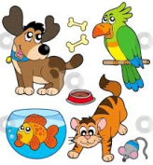


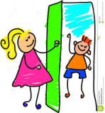


gift - doll - pet - bird - cake - candle - guest - invitation card - balloon - party hat - drink - decorate - shopping - clown - call
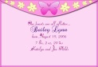

1------------------ 2--------------------- 3 --------------- 4------------------- 5------------------- 6----------------- 7------------------- 8-----------------
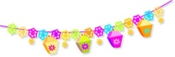

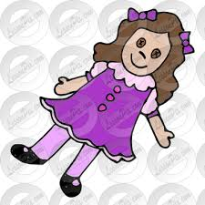


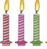
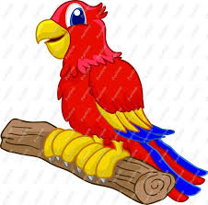
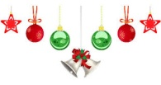

9------------------ 10------------------ 11 ---------------- 12------------------ 13---------------- 14----------------- 15-------------------
F) Boşlukları on - in - at ile doldurun.
1. My birthday in ____ March. 2. His birthday is ____ 15th June. 3. I get up ____ 7:00 o'clock everyday.
4. I don't go to school ____ Sundays. 5. Osman's birthday is ____ 3rd November. 6. Samet's birthday is ____ May.
G) Diyaloglardaki cümlelerin devamlarını bulun.
1. When is your birthday? A. You are welcome.
2. Does she like birds? B. It is on 11th April.
3. Can I have my birthday party at home, mum? C. Of course, you can.
4. Do you need a birthday cake? D. Yes, she does.
5. Thank you very much. E. No, we have a cake.

