Öğrencinin Adı Soyadı: No: Sınıfı:
A. Read the definitions and complete the words. Then, match with the correct pictures. ^{6x2=12p}
a 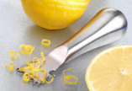 b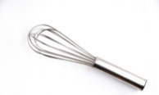 c 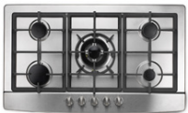 d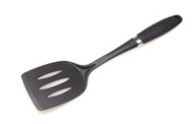e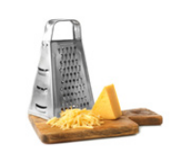f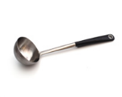
___ 1. You can cut cheese into small pieces with a ___ r ___ ___ ___ r
___ 2. You can turn over something in a frying pan with a s ___ ___ t ___ ___ ___
___ 3. You can mix a cake mixture with a ___ h ___ s ___
___ 4. You can serve soup into plates with a ___ a ___ ___ e
___ 5. You can heat the meal in a pot on a ___ o ___ ___ e ___
___ 6. You can remove a lemon’s thin skin with a z ___ ___ ___ e ___
B. Write the words about the kitchen accidents under the correct pictures. ^{5x2=10}
cut fall burn fire electric schock
a  b  c 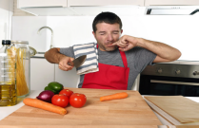 d 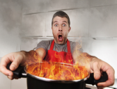 f 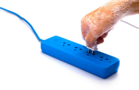
C. Match five of words with the definitions. ^{5x2=10}

1. physical harm or damage to someone’s body
2. a device or piece of equipment
3. to give a lot of attention
4. out of danger
5. something that is very important
A. ____ safe and sound
B. ____ appliance
C. ____ priority
D. ____ focus on
E. ____ injury

D. Write the job of the staff under the pictures. ^{3x5=15p}
1  2 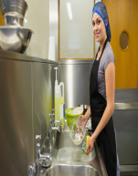 3 
d __ __ i __ __ e __ __ t __w __ __ d __ __ i __ __ e __ s
E. Complete the sentences with the words given below. ^{5x3=15p}

a. cleaver/butcher – chef’s b. serrated c. chef’s d. thin and flexible e. cleaver/butcher

1. Chefs and ______________ knives have large blades.
2. Slicing bread is easy with a blade that has a ______________ edge.
3. Cooks prefer the ______________ knife to cut vegetables.
4. I don’t damage fish when I use a knife with a thin and ______________ blade.
5. I use my ______________ knife to cut meat before I cook it.
F. Complete the sentences with the words given below. ^{5x2=10}
a. extinguish b. prevent c. first aid d. culinary e. loose
A: You’re always wearing ¹____________ clothes in the kitchen. Be careful! They can catch fire.
B: OK. I’ll keep this in my mind.
A: Do you have any ² ____________ equipment? For example, what would you apply when there is a cut in a hand?
B: I would apply some disinfectant and a plaster.
A: What do you do to ³____________ the falls in the kitchen?
B: I clean up the liquid on the floor right away.
A: To become a top chef, come to my ⁴______________ class. Study with the professional chefs and experience to cook the most delicious meals ever.
B: What are the conditions to sign up for the course?
A: Do you know how to ⁵______________ the fire?
B: No, but I know how to prevent it.
G. Complete dialogue between Jane and Kitchen Appliances with the words given below. ^{9x2= 18p}
a. stove b. cooker c. potato d. blades e. button f. food processor g. frying h. fire ı. bowl

A
J : You can do it, Jade. You can cook delicious
meatballs with baked potatoes. Now, I should
start with onions. How can I chop them quickly?
KA : I can help you.
J : You? But how? You have only a 1_________ on you.
KA : Don’t forget my chopping 2_________
Place the lid on the bowl. Then, just push my 3_________ and chop the onions.
J : You’re a great friend. Thank you, 4_________.

B
J : Meatballs are ready. Now, …
KA : Now, you need me.
J : Yes. First, I’ll heat the 5_________ pan on you.
KA : OK. Switch on the gas button and lit the 6_________.
J : All right. I’ll put the meatballs into the pan.
KA : Give me 15 minutes to cook them.
J : Thank you, 7_________. You’re very helpful.

C
KA : Jade, are the 8_________ wedges ready?
J : Yes, they are on the tray. I’ll add some more oil and salt. Now, are you ready?
KA : No! First, preheat me to 200° for about 15 minutes. Then, place the tray inside me.
J : Well done, 9_________! Now, potatoes look perfect.

H. Complete the sentences with the ways of giving advice. ^{5x2=10p}

pay attention don’t leave be careful shouldn’t wear should go

- You ____________________ to the emergency room.
- You ___________________loose clothes while cooking.

- __________________ to what you’re doing.
- _______________________ the knives lying around.
- ___________________ while chopping.

GD LUCK!
Department of English

