- Answer the question according to the dialogue and the table.

Mary: Are you free at the weekend?
Cindy: Why dou you ask?
Mary: I would like to do shopping with you.
Cindy: ……………………………………………………….
Choose the correct option to complete the dailogue.
- Sorry, my mother and I will clean the house.
- No, I will visit my uncle on Friday.
- Sorry, my sister and I will got to the cinema.
- No, I have to do my homeworks.

- Answer the question according to the dialogue.
Customer: Hello. Tom speaking. I would like to order one pizza and a bottle of coke.
Pizza service: Hi, Mr. Tom. Of course. Would you like some dessert?
Customer: No, thank you.
Pizza service: Okay. What is your address?
Customer: It is susame street.
Pizza service: ……………………..
Customer: It is susame street.
Pizza service: Okay. Have a nice day.
Choose the correct option to complete the dialogue.
- Can you repeat it, please?
- May I ask who is calling?
- Can I have your birthday?
- May I talk to the manager?

In the past, people used different ways to communicate. First soldiers used smoke signals to warn their commanders. Then Abbasids used messenger birds to have information. And today, some people write a letter.
- Which one is NOT mentioned above?
-  B) 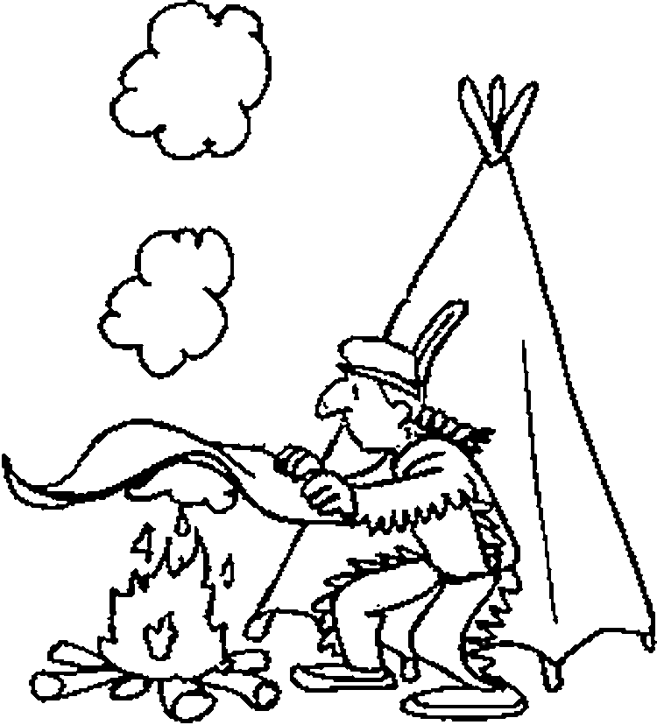 C) D) 

- Answer the question according to the dialogue and the table.
Monday | Tuesday | Friday | Saturday | Sunday
Go to cinema with sister | Do the homeworks | Visit my uncle | Clean the house with  mother | Read a book at home
Call center: Turkish Airlines. How can I help you?
Customer: I would like to make a reservation from Yozgat to Ankara on Saturday.
Call center: Single or return?
Customer: Single ticket please.
Call center: Okay. Can I have your name and phone number?
Customer: My name is Mahmut. My phone number is 4154034.
Call center: …
Customer: It is 4-1-5-4-0-3-4.
Call center: Your flight is reserved.

Choose the correct option to complete the dailogue.
- Can I have your birthday, please?
- How much does the ticket cost?
- Can you hang on a minute, please?
- Can you say your number again?

Osman: Is Ahmet at home?
Secretary: No, he is not avaliable at the moment. Would you like to leave a message?
Osman: Yes. Can you tell him to call Mr. Demir, please?
Secretary: ….
Osman: Can you tell him to call Mr. Demir, please?
Secretary: Of course.

- Which one does NOT completes the dialogue?
- Say it again, please.
- I beg your pardon.
- Hang on a minute.
- Repeat it, please.

 |  |  | 
French Teenagers | 
American
Teenagers
Look at the table and the text. Answer to the questions.
This is our research about teenagers’ daily routines. We compared the young people in France and America.
- Which sentence can be CORRECT according to the research results?
- American teens’ favorite activity is reading a book.
- French teens are more interested in playing soccer than American teens.
- French teens prefer reading a book to watching television.
- American teens loves sports more than reading.

- Answer the question according to the dialogue.
Call center: How can I help you?
Tina: I would like to learn about my electricity bill.
Call center: Okay. ……………………………………
Tina: Tina Redstone.
Call center: You will pay 100 dollars for electricity this month.
Tina: Got it. Thank you so much.
Call center: You are welcome. Have a nice day.
Choose the correct option to complete the dialogue.
- Would you like to leave a message?
- Can you say it slowly, please?
- Can I have your full name, please?
- May I speak to your sister, please?

My Future Plans
I will get an motorbike on my next birthday. I will get a laptop when I turn eighteen. I will be an English teacher when I graduate from the university. I won’t buy a car and a house because they are very expensive. I will travel the world in the summer holidays. I will probably get married and have children in my thirties.

- Which of the followings is NOT answered in the text?
- What will you do in the summer?
- When will you get married?
- Why won’t you buy a house?
Ways of communication
- Text a message.
- Talking face to face.
- Write a diary.
- Make phone call.
- Where will you live 10 years later?

- Choose the odd one. Which one is Not a way of commuication?
- Write a diary.
- Text a message.
- Talking face to face.
- Make phone call.

Call center: Hi. Ford cars Turkey. How can I help you?
Customer: Hello. I would like to buy the new red car. …………………………………….
Call center: It is 160.000 turkish liras.

- Choose the correct option to complete the dialogue.
- Can you say it slowly, please?
- How much is that car cost?
- What color is that car?
- Can you call the manager, please?

