Irregular Verbs – QUIZ

Name: Class: Number:

- Write the second form (Verb-2) of the words given below.
(Aşağıda parantez içerisinde verilen fiilerin 2. hallerini yazınız.)
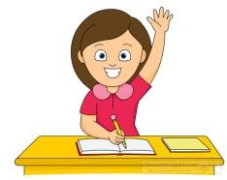
- I ……………... (hear) a new song on the radio.
- You ……………... (read) three books last week.
- They ……………... (begin) to run in the forest yesterday.
- He ……………... (see) a cat in the school last week.
- I ……………... (go) to cinema with my friends on Sunday.
- She ……………... (buy) a car in 2017 for her mother.
- We ……………... (come) to home late 2 days ago.
- Ali ……………... (do) his homework after school.
- My father ……………... (drink) too much tea yesterday.
- Your friend ……………... (drive) to hospital 4 hours ago.

- Choose the right option and circle it according to Past Tense.
(Doğru olanı kelimeyi geçmiş zamana göre seç ve daire içerisine al.)
- Mary (eat / ate / aet) a very big hamburger at the cafe.
- Sally (found / find / finded) the lost money yesterday.
- The bird (fly / flew / flow) out from the window.
- You (forget / forgot/ forgetted) to do your homework last day.
- I (give / gave / given) my car to Mehmet last week.
- Jack (have / had / has) breakfast in Konya today.
- I (know / knew/ knowed) you were at school 3 weeks ago.
- My sister (leave / live / left) the home at 3 o’clock yesterday.
- Merve (become / became / becume) a teacher in 2015.
- She (lose / losed / lost) your book at home last month.
- Fill in the blanks below. (Boşlukları uygun şekilde doldurunuz.)
 | VERB - 1 | PAST SIMPLE / VERB - 2 | MEANING (Anlam)
1 | make | ……………………. | yapmak
2 | ……………………. | taught | öğrenmek
3 | meet | made | …………………….
4 | read | ……………………. | okumak
5 | ……………………. | ran | koşmak
6 | spend | ……………………. | harcamak
7 | think | thought | …………………….
8 | ……………………. | swam | yüzmek
9 | see | ……………………. | yüzmek
10 | sleep | slept | …………………….
- Choose the right option and tick . True (Doğru) – False (Yanlış)

- The teacher gived English homework yesterday. TRUE FALSE
- I understood “Wh Quesitons” in the lesson last week. TRUE FALSE
- My friend wrote a letter to me last year. TRUE FALSE
- Jessica telled a story to her little sister last night. TRUE FALSE
- She sitted and waited for the bus. TRUE FALSE
- I spoke English in England in 2014. TRUE FALSE
- They ride a horse at the park last month. TRUE FALSE
- We met at the restaurant with our friends 3 days ago. TRUE FALSE
- I heared a loud music in the hospital yesterday. TRUE FALSE
- Ali did karate and yoga last day. TRUE FALSE
- Choose the right answer in the tests. (Testlerdeki doğru olan şıkkı işaretleyin.)
- She ………… the window yesterday. 2. They ……………. to dance in the class.
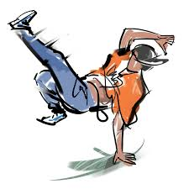
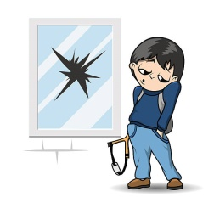
- Broke A) flew
- Left B) put
- Drank C) was
- Saw D) began

- The students ……….. their homeworks. 4. My mother ……… a cake for my birthday.
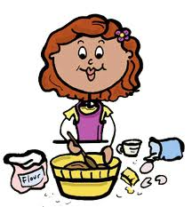
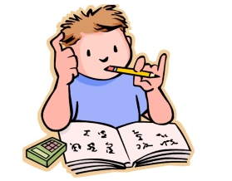
- Came A) met
- Felt B) lost
- Bought C) made
- Went D) lost

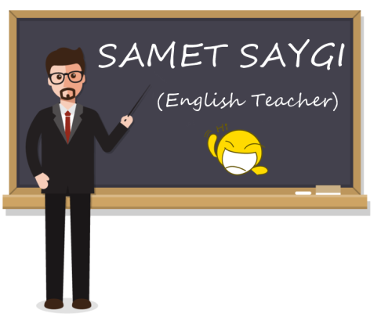
5. Reyhan …… a gift (hediye) for Ali last week.
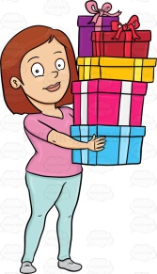
A) became
B) bought
C) drank
D) fought

