5th GRADE 3rd UNIT QUIZ

Doğru şıkkı işaretleyin
(20x3=60)

B. Cümleleri kutudan seçeceğiniz kelimelerle tamamlayın (10x2=20p)
Take photos - play chess - draw - sing a song - play basketball - paint - play guitar - swim - run fast - play football

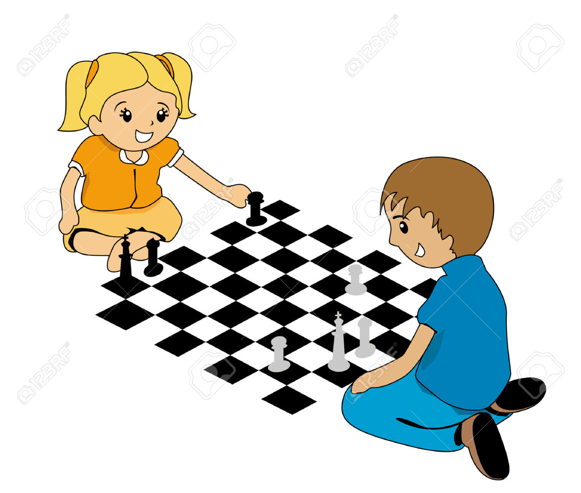

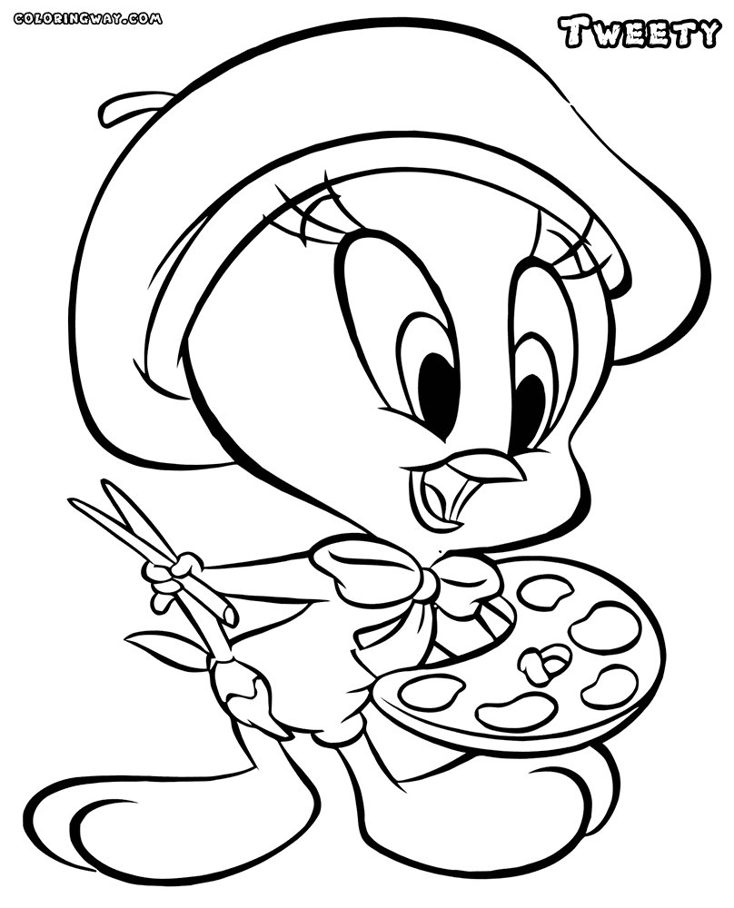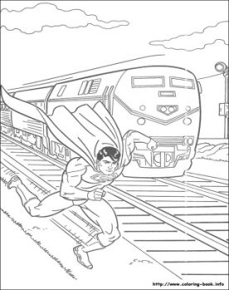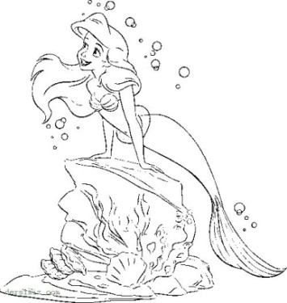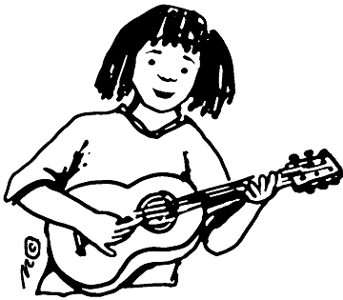
I can’t ……………….. – They can …………………. – I can…………………….- She can ………………….. – She can’t …………….
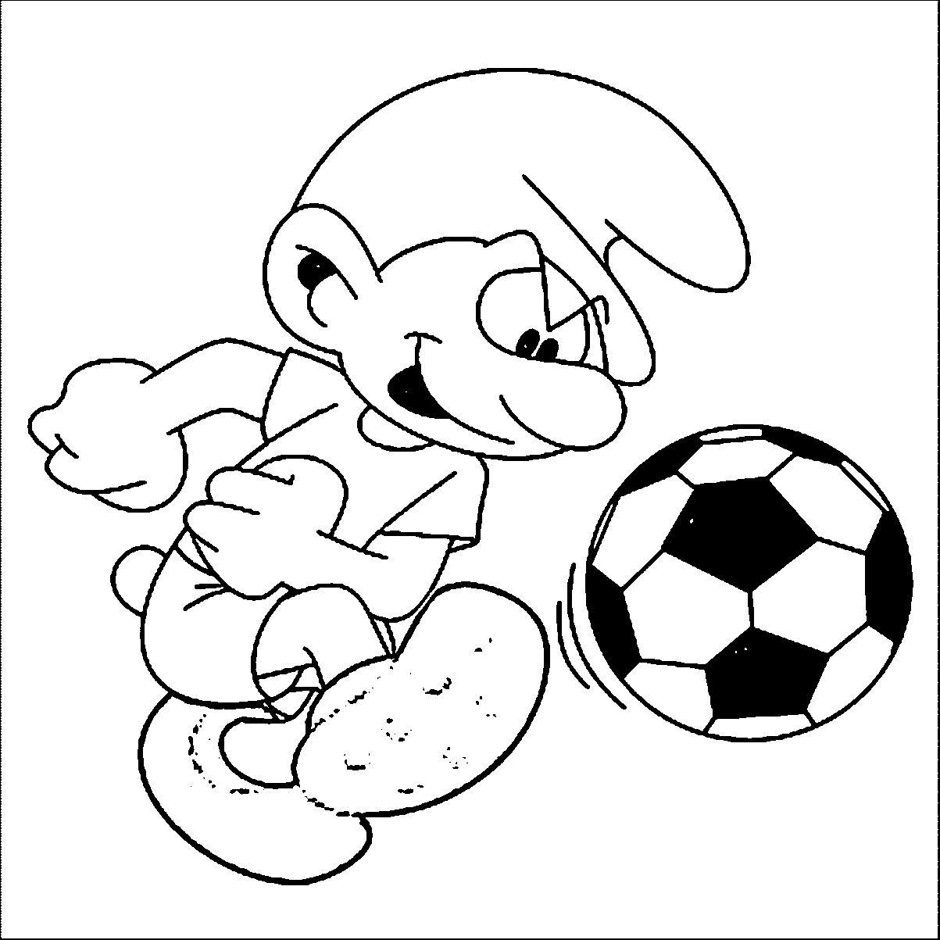
She can’t ………………… - He can ……………………. - She can’t …………………….- They can ………………..- They can …………….





c. Cümleleri I like – I don’t like kullanarak kutudan seçtiğiniz fiillerle cümle yazın.(5x4=20p)



1)………..…………..… 2) …………..…………….. 3)………………… ……….. 4)………………………………… 5)………………………….
Playing basketball -- playing tennis -- swimming --- watching tv --- playing football

