EXERCISES A) Fill ın the blanks with the suitable words below
riding- reading- playing (2)- singing- writing- flying- watching-
cooking-listening

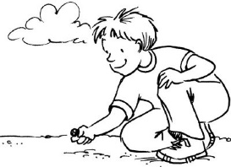

- I like-------- comics.
- Do you like -------- with marbles.?
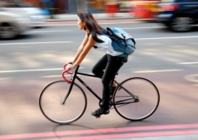
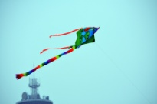
- You don’t like------- to classical music.
- We like ---------- a kite.
- They like ------- a bicycle.

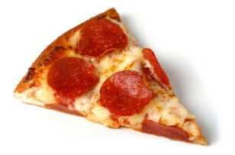
- I don’t like-------- computer games.
- We like --------- cartoons.

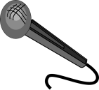
- I don’t like -------- pizza .

- Do they like ------- a song?
10)You like ------- a letter.

swimming–dancing-playing(2)-drinking- coloring-jumping- doing-eating- driving)
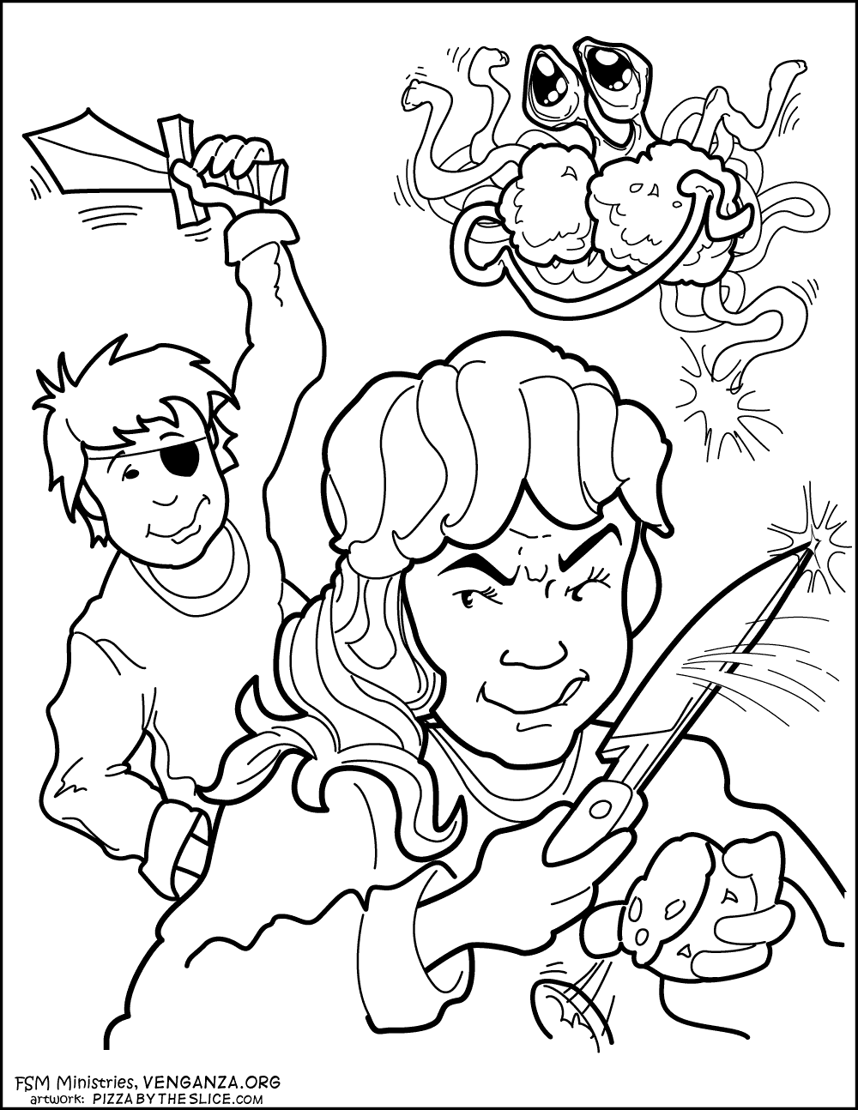

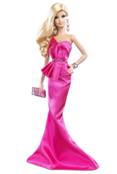
1) We like ------------- cookies.
2) The girls like ------------chess.
3) Do you like ------------ a car ?

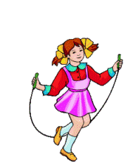
4) We don’t like---------- coca-cola.
5) I like------------- in the sea.

6) Do they like ---------- pictures ?
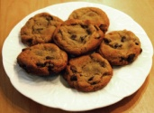
7) We like ------------ at parties.
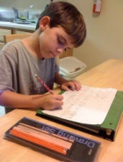
8) I like -------------- my homework.
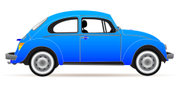

9) We like ----------- rope. 10) Do you like ---------- with dolls ?
B) Answer the questions about you.

- What is your favourite activity? --------------------------
2) Who is your favourite cartoon character ?-------------------

3) Do you like reading a book ? ---------------------------------------
4) What do you like eating for breakfast in the mornings ?
----------------------------------------------
5) Where do you like riding a bike ? ----------------------------------
6) What time do you like getting up at weekends ? ---------------------------------
7) Where do you like having lunch at school or home ? -----------------------------------------
8) Who do you like playing with in the school garden at breaks? --------------------------------------------
9) Where do you like swimming ,in the pool or sea ? -------------------------------------------
10) Do you like going to the cinema ? -------------------------------------

C) Fill in the blanks with AND or BUT.
1)I like running ------ climbing a tree. 2)The boys like playing football ------ they don’t like playing with dolls
3)My sisters like going to the cinema------- they don’t like jumping rope.
4) We like doing our homework -------- exercises.
5) They like playing the guitar ------- singing songs.
6) We like eating bananas -------- we don’t like eating hamburgers.
7) My parents like playing chess ------- they don’t like playing tennis.
8) You like drinking milk ------- fruit juice.
9) Paul and Mary like riding a horse ------- they don’t like jogging.
10) I like playing basketball ---- volleyball.

D) WORD ORDER ( Like + verb_{-ing} ) Please Use long answers

Eg: You/like/ride /a bike/ Do you like riding a bike?
Yes, I like riding a bike.
No, I don’t like riding a bike.
1) You / like / read/ a book/ ---------------------------------?
Yes, ---------------------------
No, --------------------------
2) They /like/ watch/ cartoons/---------------------------------?
Yes,-------------------------------------
No, --------------------------------------
3) The boys /like / play/ with /marbles/--------------------------?
Yes,----------------------------------
No,----------------------------------
4) Your friends /like /eat / ice-cream/ ---------------------------?
Yes,------------------------
No, -----------------------
5 ) The students/like/ play/ hopscotch/ ---------------------------?
Yes, ------------------------------
No,-------------------------------
6) You /like / swim /in the sea /--------------------------------?
Yes, -------------------------------
No,--------------------------------
7) Bob and David /like / listen/ to music /--------------------------?
Yes,------------------------------
No,-------------------------------
8) You/like/fly/a kite /---------------------------------------?
Yes,---------------------------------
No,---------------------------------
9) They/like/visit/the museum/ -------------------------------?
Yes,--------------------------------
No,-----------------------------------
10)You/ like/ paint/pictures/ -------------------------?
Yes,----------------------------------
No,----------------------------------. Lütfiye TIN ELT.

