**UNIT 3 CARTOON CHARACTERS**

MY

YOUR

HERR

HIS

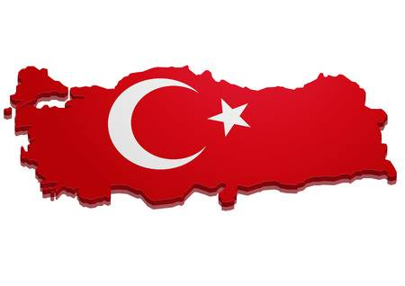

What is **your** name?

This is **my** country.

**My** name is ……………

This is **your** country.

**Write his / her**

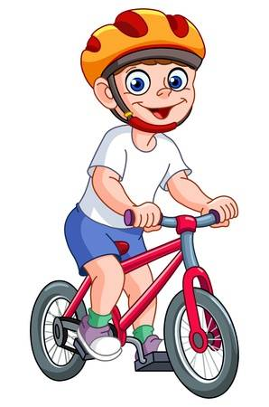

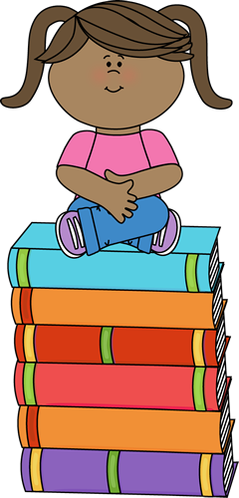



These are ………………… books.

This is ………………… bike .

This is ………………… ball .

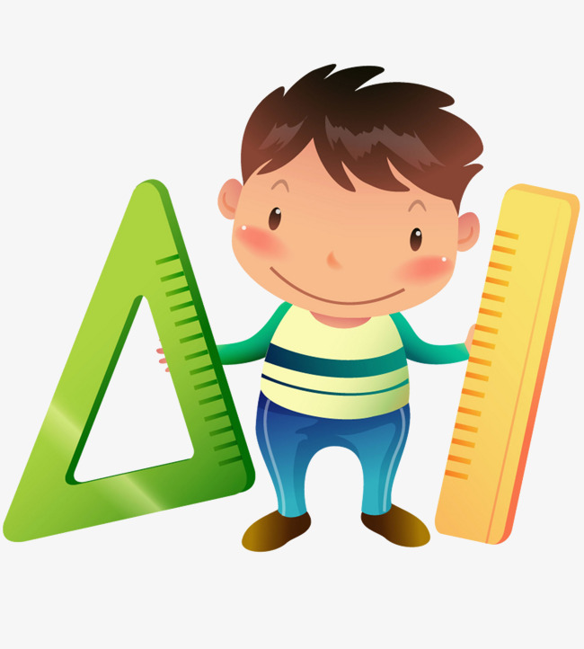

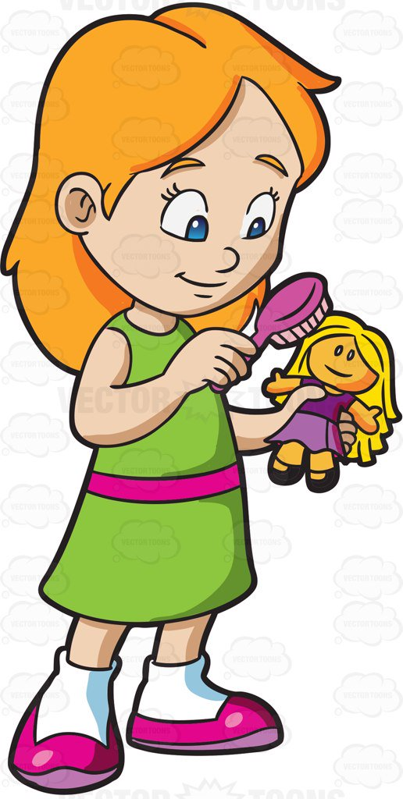

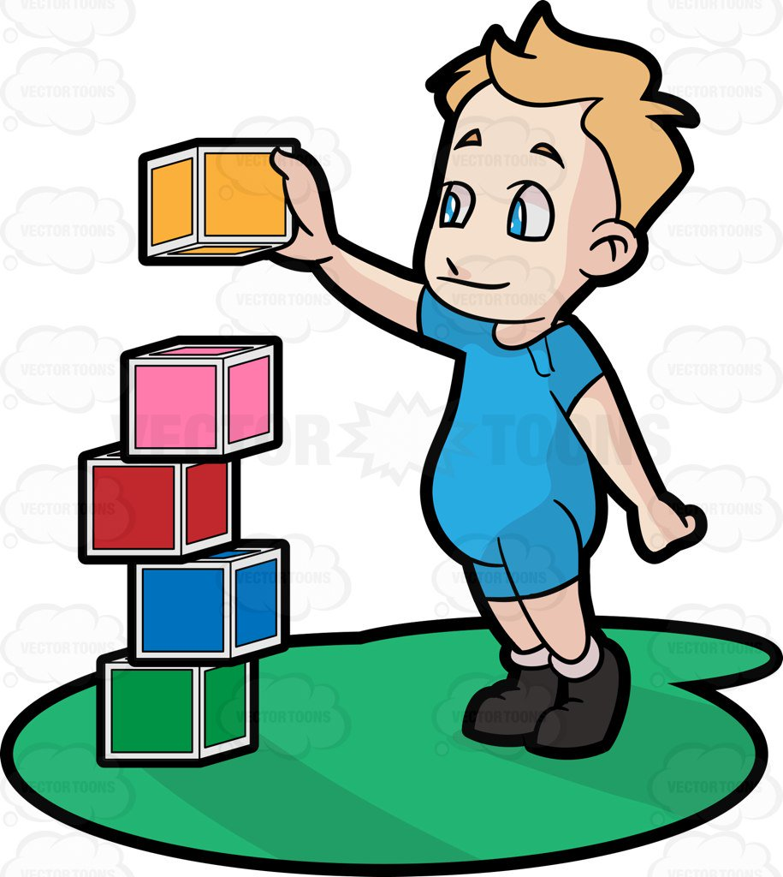

These are ………………… rulers .

This is ………………… doll .

These are ………………… blocks .



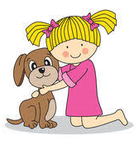

Elif ARSLAN ÇELE

English Language Teacher

This is ………………… pencil .

This is ………………… dog .