TOYS
Find and color. (Bul ve boya.)
3
1
2
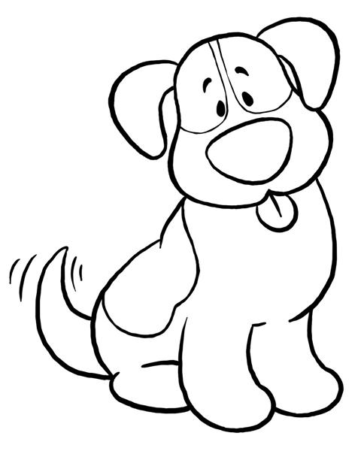
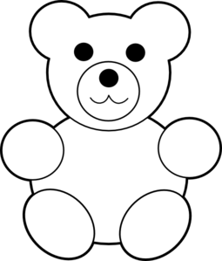
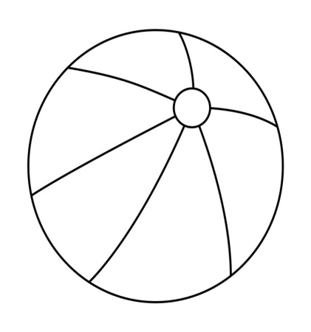

6
5
4
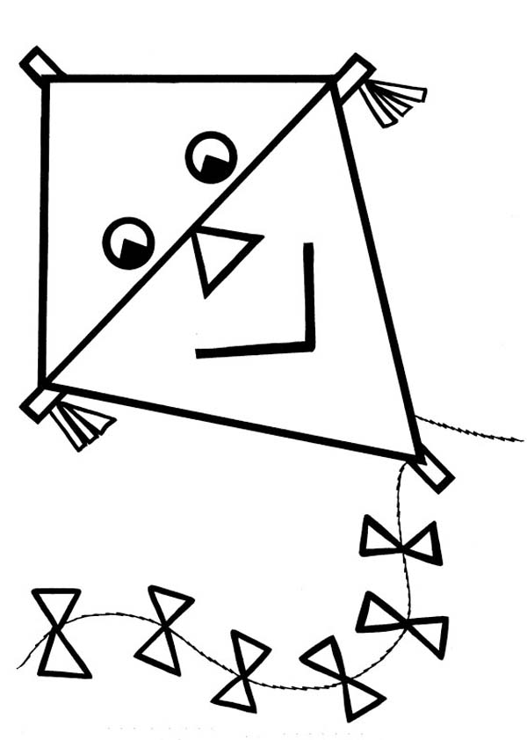
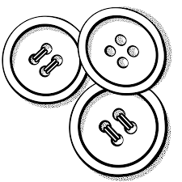
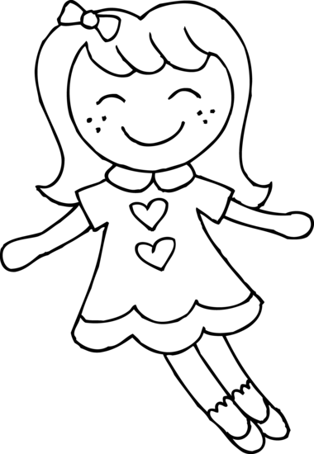

9
8
7
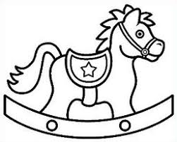
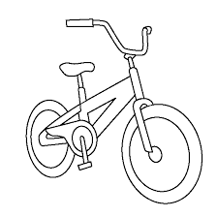
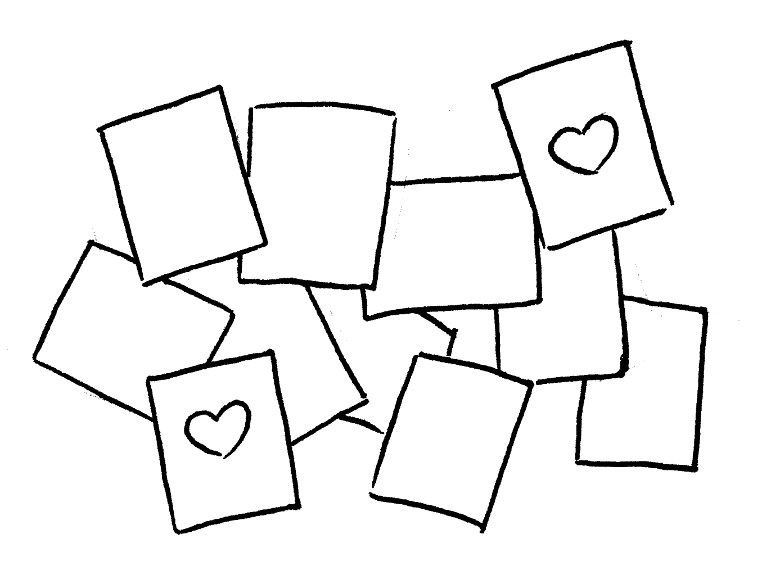

I have got a toy horse.
It is brown.
I have got buttons.
They are red.
I have got a toy dog.
It is black and white.

I have got a ball.
It is green.
I have got a teddy bear.
It is yellow.
I have got a kite.
It is purple.

I have got a doll.
It is pink.
I have got a bike.
It is blue.
I have got playing cards.
They are colourful.

Find and color. (Bul ve boya.)
3
1
2
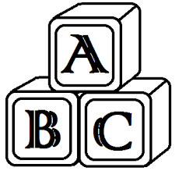
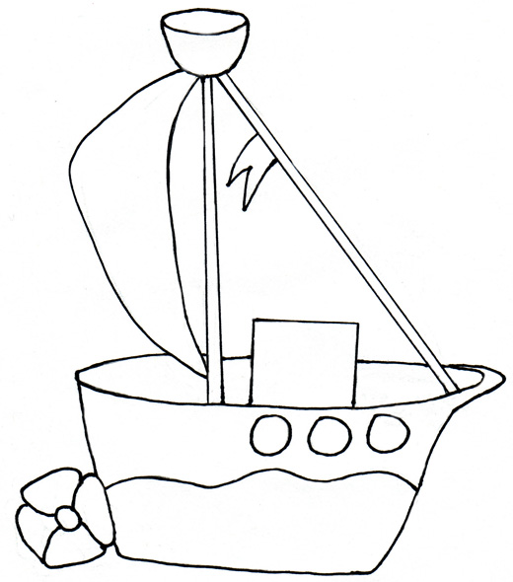
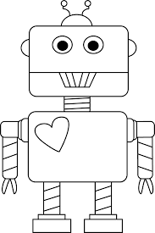

6
5
4
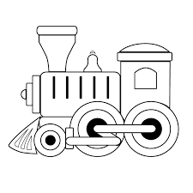
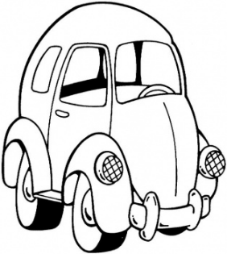
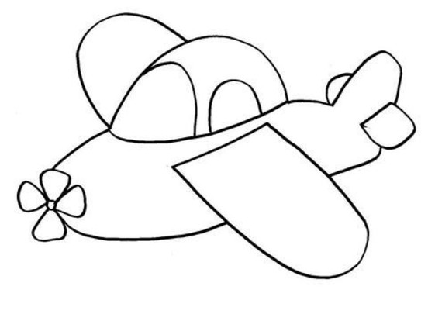

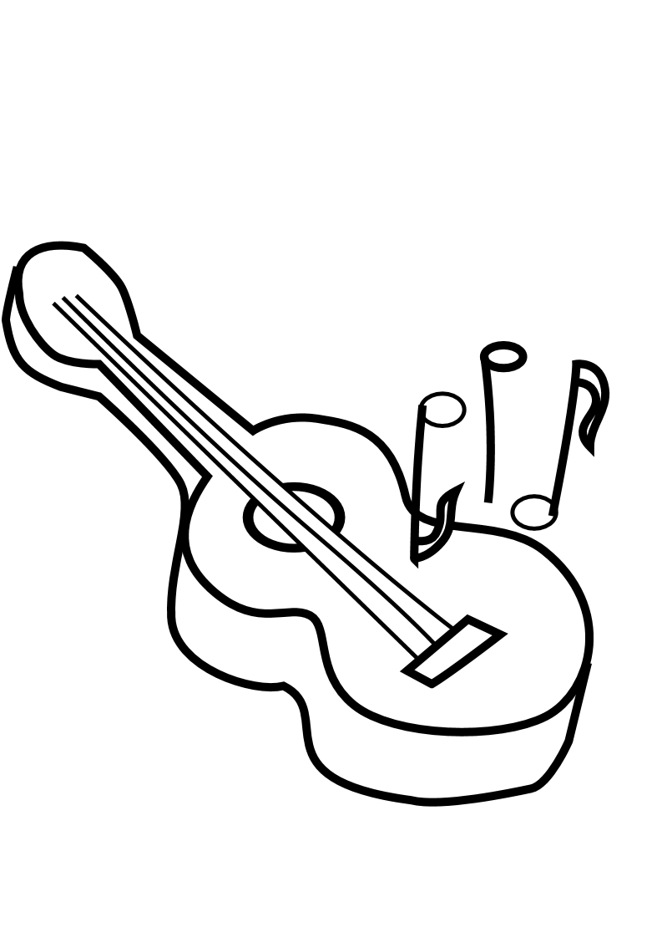
9
8
7
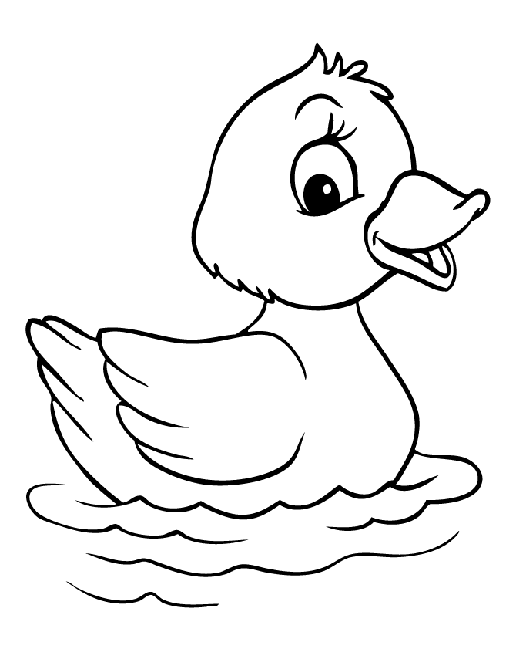
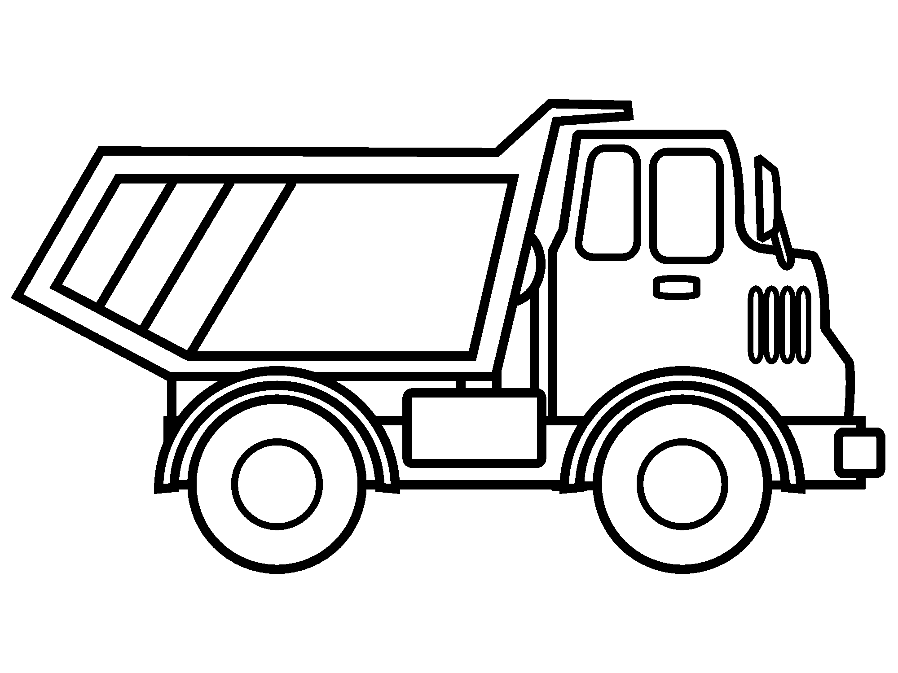

I have got a toy truck.
It is red and black.
I have got a toy robot.
It is grey.
I have got a toy car.
It is blue.

I have got a toy plane.
It is green.
I have got a toy duck.
It is yellow.
I have got blocks.
They are purple and pink.

I have got a toy guitar.
It is red.
I have got a toy ship.
It is brown.
I have got a toy train.
It is orange.

Elif ARSLAN ÇELE
English Language Teacher

