TOYS
Read and find the picture. (Oku ve resmi bul.)
3
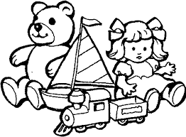
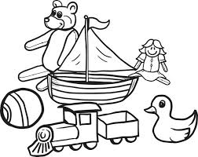
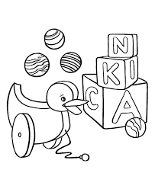
1
2

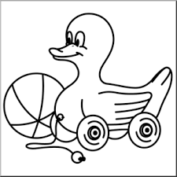
6
5
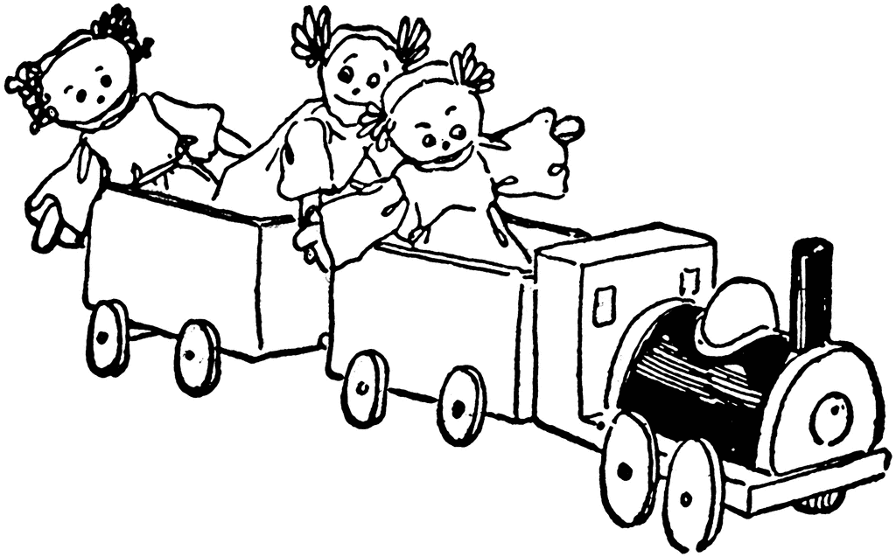
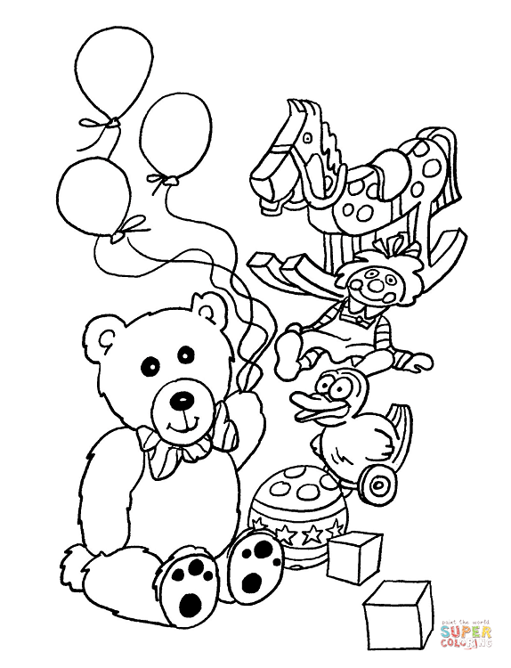
4

I have got a toy duck, four balloons and three blocks.

I have got a toy train and three dolls.

I have got a toy ship, a toy train, a doll and a teddy bear.

I have got a teddy bear, a ball, a toy duck, a toy horse, a doll, two blocks,
and three balloons.

I have got a toy duck and a ball.

I have got a teddy bear, a ball, a toy duck, a toy ship a toy train and a doll.

HOW MANY …?

Count and answer. (Say ve cevapla.)
How many playing cards are there?
There are ten playing cards.

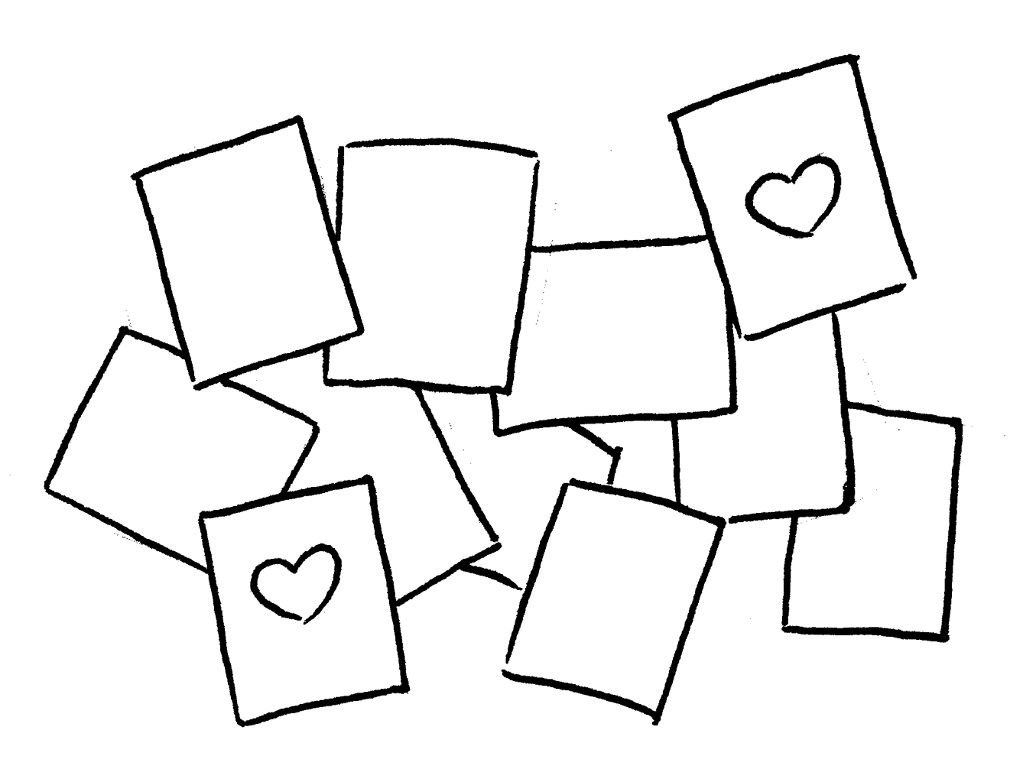

How many balls are there?
There are …………………………………………………………………………

1
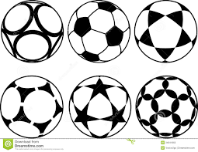

2
How many ballons are there?
……………………………………………………………………………………………

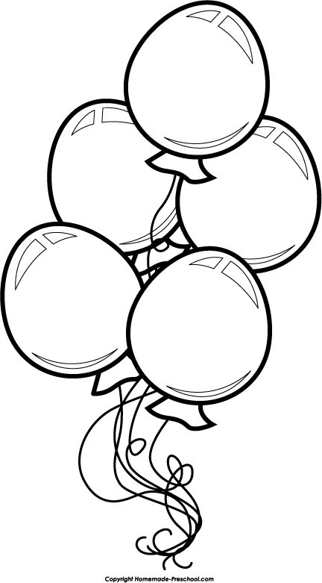

3
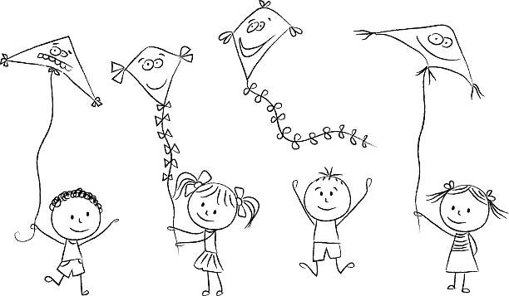
How many kites are there?
……………………………………………………………………………………………

4
How many blocks are there?
……………………………………………………………………………………………

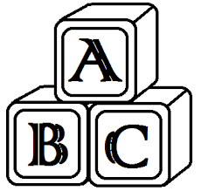

5
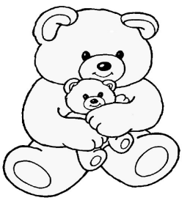
How many teddy bears are there?
……………………………………………………………………………………………

