GENERAL REVISION FOR 3rd GRADES
(3. SINIFLAR İÇİN GENEL TEKRAR)
Aşağıdaki İngilizce ifadelerin Türkçelerini yan taraftan bulup yazınız.
hello/ hi ..........................................................
Goodbye/bye .....................................................
take care .............................................................
have a good day .................................................
have a nice weekend ..........................................
good afternoon .................................................
good evening .................................................
good night .................................................
Spell your name ...........................................
How old are you? ...........................................
How are you? .................................................
Cut .................................................
Write .................................................
Stick .................................................
family ................................................
cousin .............................................
brother .........................................
sister ...........................................
grandfather ................................
grandmother ...................................
uncle ...................................
aunt ......................................
who .....................................
my family ...................................
thin/slim ....................................
fat/heavy .......................................
Nasılsın ?
İyi günler
Yazmak
İyi hafta sonları
Hoşçakal
İsminin harflerini söyle
Yapıştırmak
Kuzen
Kendine iyi bak
merhaba
Tünaydın/ iyi öğlenler
Aile
Benim ailem
Şiman/ağır/kilolu
Teyze/hala
Büyük anne
Büyük baba
Amca/dayı
Kİm?
İnce/zayıf
Kaç yaşındasın?
kız kardeş
erkek kardeş
iyi akşamlar
iyi geceler
kesmek

Write the numbers (Sayıları İngilizce yazınız)
1  ..................................... | 2  ..................................... | 3  ..................................... | 4  .....................................
5  ..................................... | 6  ..................................... | 7  ..................................... | 8  .....................................
9  ..................................... | 10  ..................................... | 11  ..................................... | 12  .....................................
13  ..................................... | 14  ..................................... | 15  ..................................... | 16  .....................................
17  ..................................... | 18  ..................................... | 19  ..................................... | 20  .....................................

Write the adjectives (Sıfatları yazınız) (big,small,strong,weak,tall,short,heavy,slim,old,young,fast,slow)
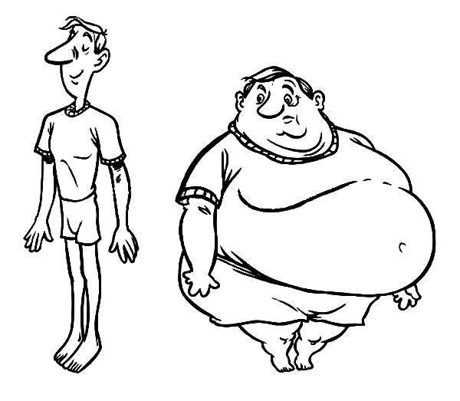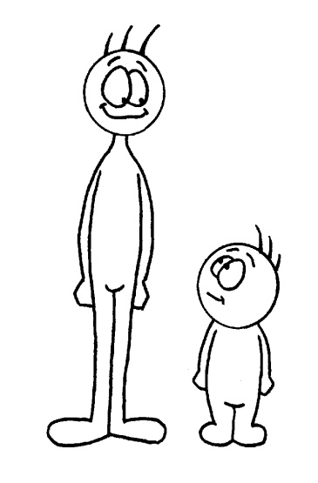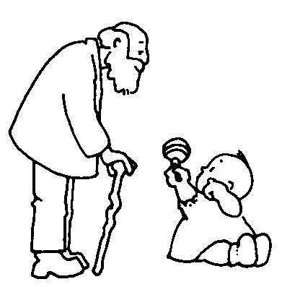
...................... ...................... .................... .................... ........................ ...................
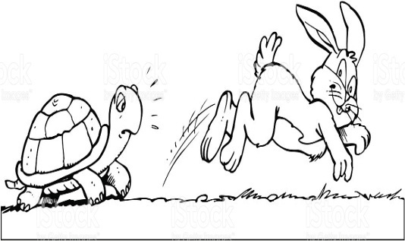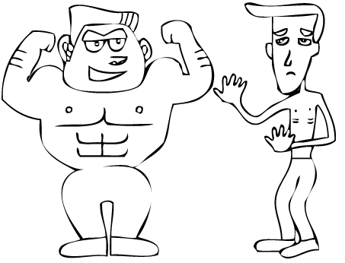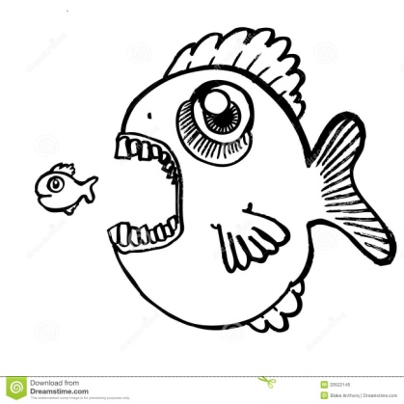
..................... ......................... ...................... ................... ................. ...........................

Write the sentences under the pictures. CAN ( YAPABİLMEK) CAN'T (YAPAMAMAK)
She can fly. He can sing. He can run fast. She can't cook. He can ride a bike.
She can swim. It can climb a tree. She can skip a rope. He can't play football.
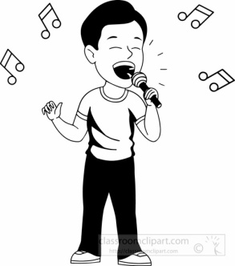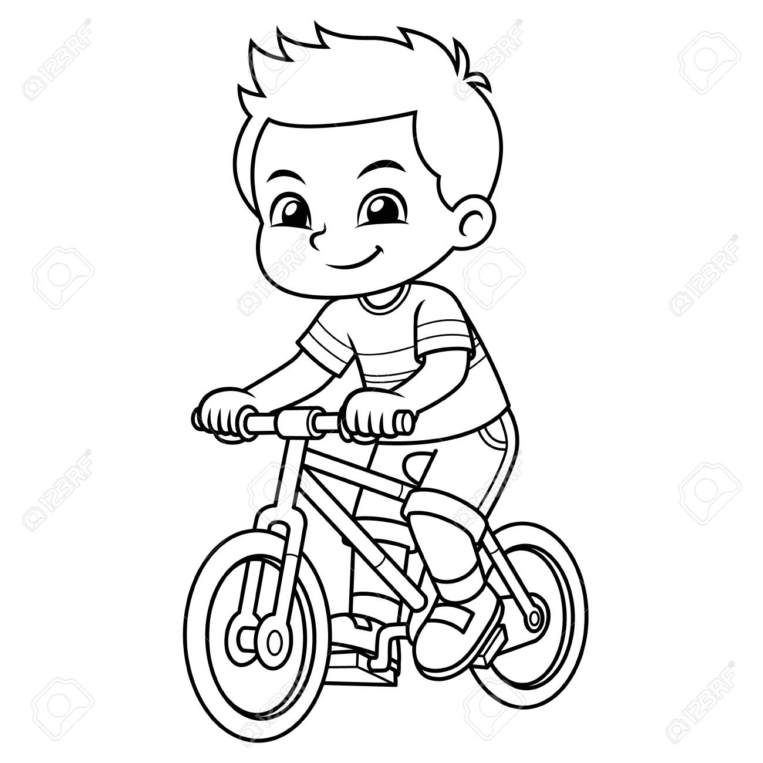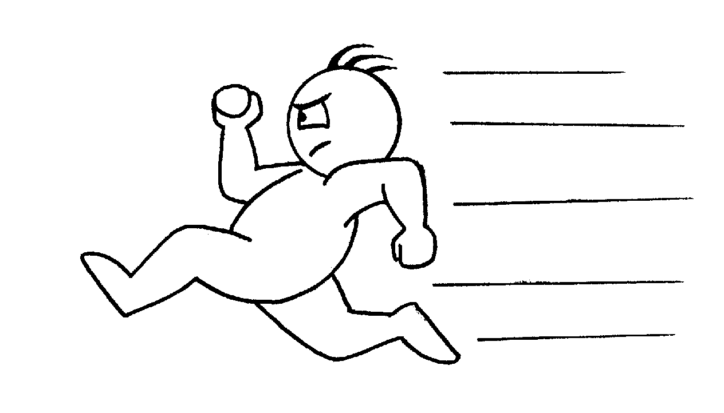
........................................................ ....................................................... ...........................................................
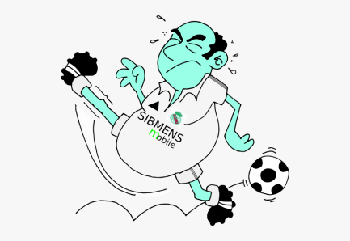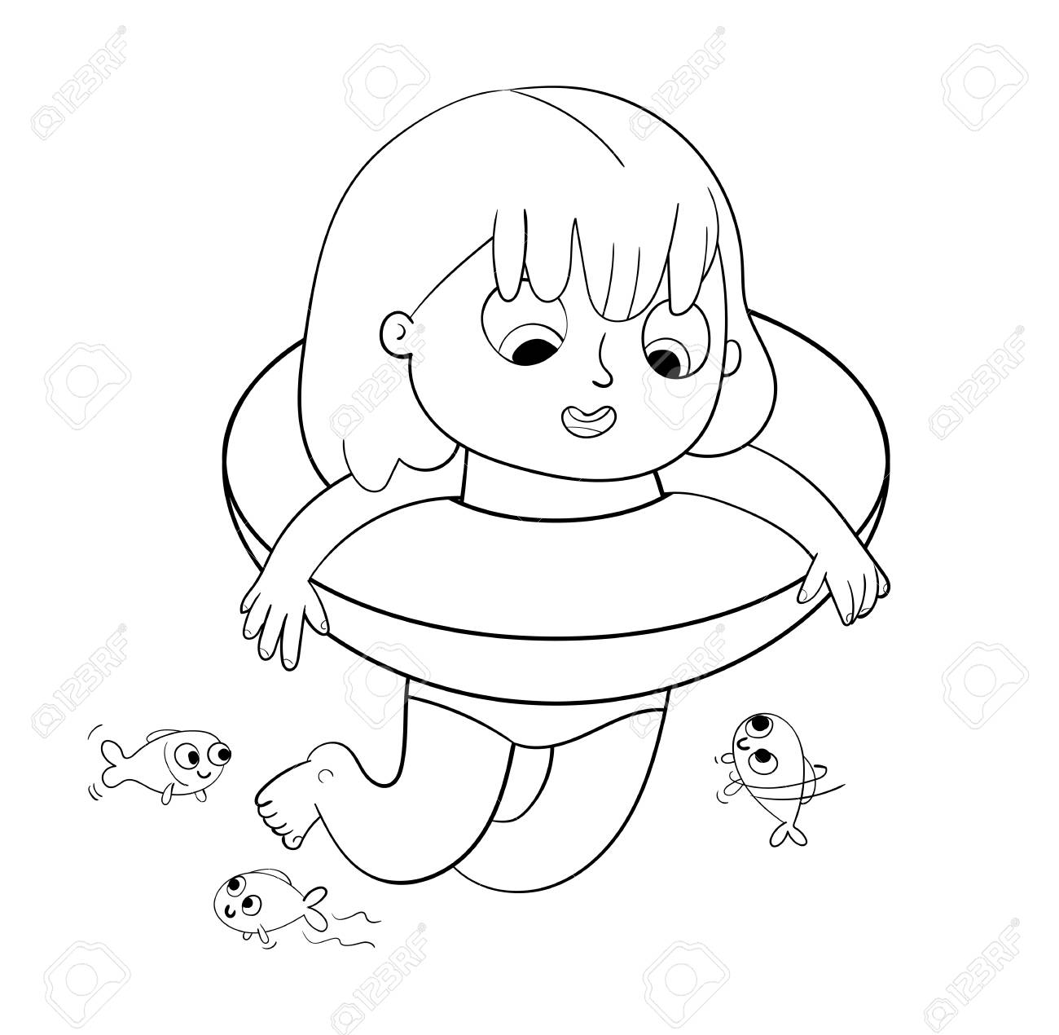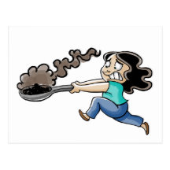
..................................................... ....................................................... .....................................................
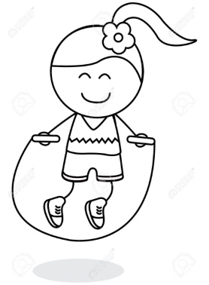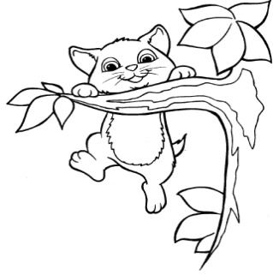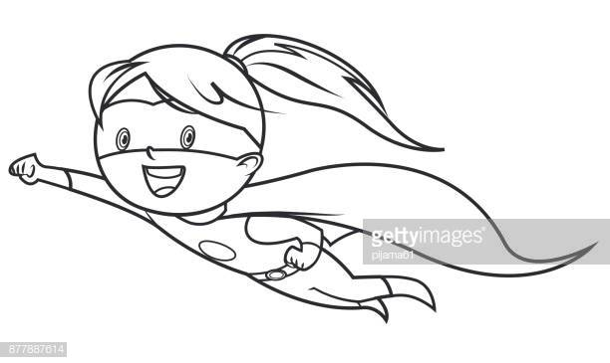
..................................................... ....................................................... .................................................................

ANSWER THE QUESTIONS. USE Yes,I can(Evet yapabilirim) No, I can't (Hayır yapamam)
Can you play basketball? (Basketbol oynayabilir misin?) .....................................................
Can you play tennis? ...................................................................
Can you dance? ..........................................................................
Can you draw pictures? ........................................................................
Can you ride a horse? ...............................................................................
Can you jump rope?? ........................................................................
Can you fly?? ...............................................................................

HOW DO YOU FEEL? (NASIL HİSSEDİYORSUN?
good/okay bad tired angry hungry sleepy happy surprised sad/unhappy energetic
I feel ...................... I feel ............................ I feel ....................... .............................................
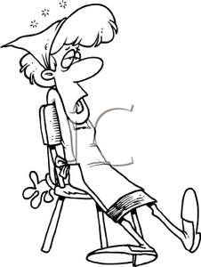 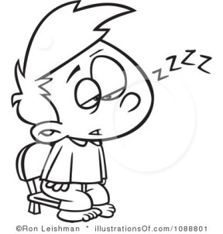 ................................... ........................................... ..............................................
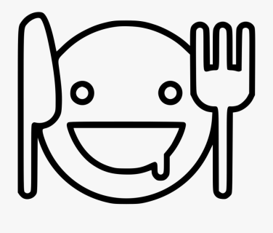.............................................. .............................................. .....................................................
(RESİMDEKİ öNERİLERDE BULUNUN) LET'S (HAYDİ)
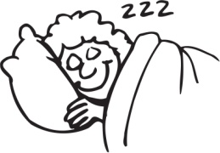 Ali: I feel tired. (Yorgun hissediyorum)
Ahmet: Let's ....................
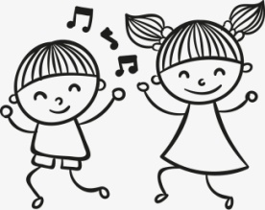Sema: I feel energetic.
Zeynep:..............................................
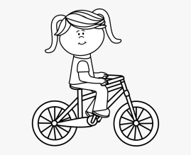Asel: I am good.
Yağmur: .......................................

