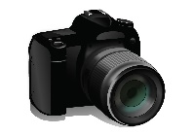
THE 3rd GRADE -- EXERCISES --
1- I have got a camera. What can I do ?
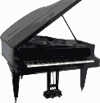
--------------------------------------
2- I have got a piano. What can I do ?
--------------------------------------
3- I have got rope. What can I do ?
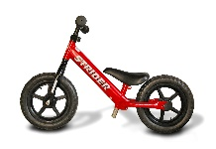
--------------------------------------
4-I have got a bike. What can I do ?
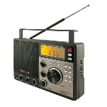
--------------------------------------
5- I have got a radio . What can I do ?
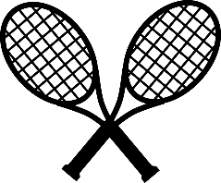
------------------------------------
6-I have got two rackets . What can I do?
--------------------------------------
7- I’m angry today. What can’t I do?
----------------------------------------
8-Ece is happy today. What can she do?
----------------------------------------
9- Memo is tired today. What can’t he do?
-----------------------------------------
10- Simay is energetic today. What can she do ?
----------------------------------------
11- Yağız is sad today. What can’t he do?
-----------------------------------------
12- Duygu and Okan feel hungry now . What can they do ?
-----------------------------------------------
13- I feel thirsty now. What can I do ?
---------------------------------------------
14- I feel bad today. What can I do ?
--------------------------------------------

