UNIT 3 PEOPLE I LOVE
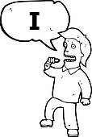



I am
I’m
You are
You’re
He is
He’s

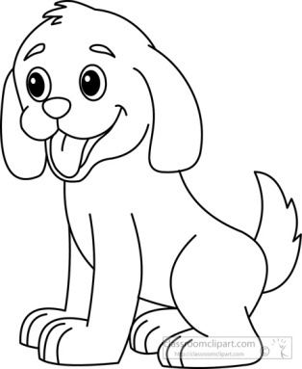

She is
She’s
It is
It’s

We are
We’re

They are
They’re

Match.
6
1

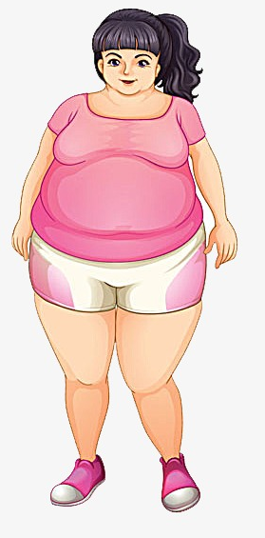

They are old.

It is slow.

7
2
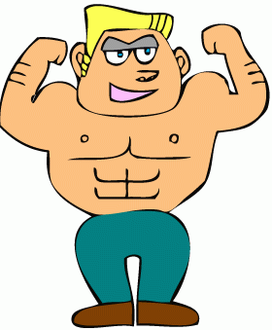
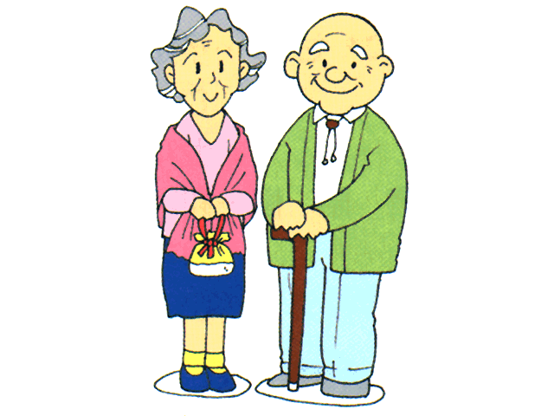
She is fat.

It is small.

3
8
He is handsome.

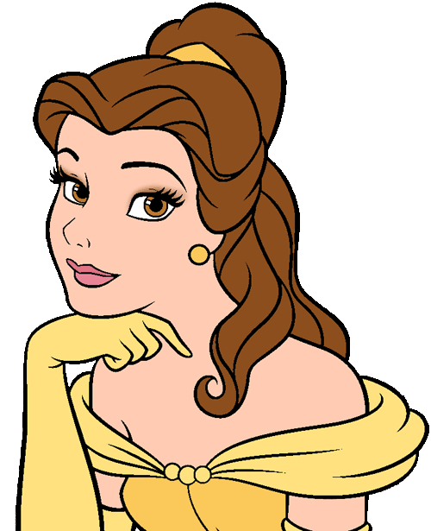
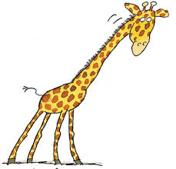

She is slim.

9
4

He is strong.



It is tall.

10
5
She is beautiful.


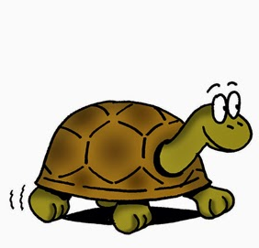

They are young.

Write sentences.
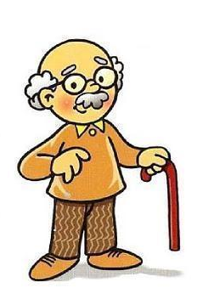

She is fat. ……………………………………….
She isn’t slim. ……………………………………….

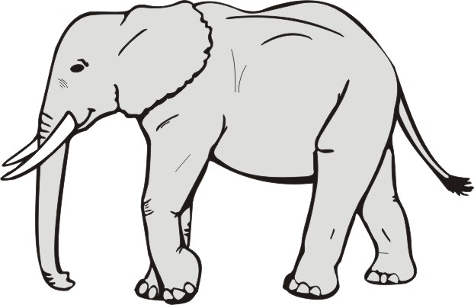
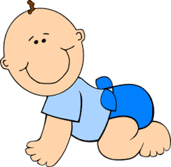
………………………………………. ……………………………………….
………………………………………. ……………………………………….



………………………………………. ……………………………………….
………………………………………. ……………………………………….

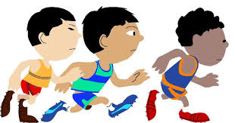

……………………………………….
……………………………………….
Elif ARSLAN ÇELE
English Language Teacher

