A)Boşlukları aile bireyleri ile doldurunuz.
1. My ………………can cook meal.
2.My ……………………… is old.She is 90.
3.My …………………. can run fast.
4.My …………………. can drive a car.
5.My …………………. is playing with her doll.
6.My …………………. is my father’s brother.
7.My …………………... is my mother’s sister.
8.My …………………… can’t run fast.He is old.
B.Eşleştiriniz.
Father Kız kardeş
Mother Baba
Sister Anne
Grandmother Erkek kardeş
Uncle Büyükanne
Brother Amca/Dayı
Grandfather Teyze/Hala
Aunt Büyükbaba
C)Aşağıdaki boşlukları “can” ya da “can’t” ile doldurunuz.
1.A bird ……….. fly but it …….. run.
2.A parrot ………… talk but it ………….. swim.
3.A fish ………….. swim but it ………….. walk.
4.An elephant ……..walk but it………..jump.
5.A monkey ……… climb but it ………. Fly.
6.A horse ……….. run but it ………… fly.
7.A cat ……….. climb but it ………… talk.
8.A turtle ……….. walk but it ……….. run.

C)Boşlukları verilen kelimeler ile doldurunuz.
strong – weak – fat – slim – fast – slow – old – young – tall – short
1.A whale is ………… but a giraffe is ………… .
2. A horse is ………… but a chick is ………… .
3.A giraffe is ………… but a chicken is ……… .
4.A turtle is ……….. but a rabbit is ………… .
5.My grandmother is …….. my brother is ………………. .
D)Eşleştiriniz.
happy üzgün hungry susamış
angry mutlu sleepy aç
sad sinirli thirsty uykulu
good mutsuz surprised yorgun
unhappy kötü scared şaşırmış
bad iyi tired korkmuş
E)Boşluklara uygun kelimeleri yazınız.
good - bad – happy – tired- angry – hungry – thirsty – surprised - scared – sleepy - sad
1.  I am …………. .
2. 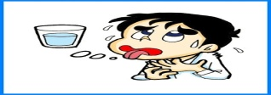I am ………………. .
3.  You are ……………. .
4.  She is ………………….. .
5. 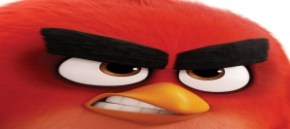 It is ……………………… .
6. He is …… .
7. 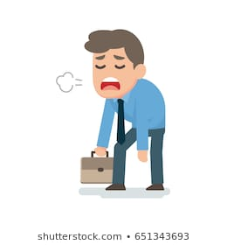He is ……………. .
8I feel ……………… .
9.  I feel ……………….. .
10. I feel ………………. .
11.  I feel …………… .
F)Verilen kelimeleri uygun boşluklara yazınız.
sleep – walk – run – watch – cook – dance – read – study – swim – eat – drink – play
1.A rabbit can ……………. fast .
2.I ………………. 8 hours a day.
3.A turtle can …………. But itcan’t …………. .
4.I ……….. Tom and Jerry on tv.
5.My mother can …………. meal.
6.I ……………. English .
7.I ……………… lunch at 12 o’clock.
8.A fish can …………….. .
9.A horse can …………. fast.
10.I …………… a book.
11.Children ……………… milk.
G)İşlemlerin sonuçlarını örnekteki gibi İngilizce yazınız.
2+1=three 6+7= 5x4=
1-1= 6+5= 3x5=
5-3= 4x3= 8x9=
1+0= 7x2= 8+8=
3+4= 2x4= 20-1=
3+2= 5+5= 8x2=
3+3= 3x3= 2+2=
H)Doğru şıkkı işaretleyiniz.
1. “How do you feel?” Sorusunun cevabı hangisi olabilir?
A)I’m young. B)I feel good. C)I’m 9.
2.”Spell your name.” Bu cümlenin uygun cevabı hangisidir?
A)M-E-R-T B)I’m okay. C) I’m Mert.
3.”What is your name?”sorusuna uygun cevap hangisidir?
A)I’m nine. B)I’m Eren. C)I’ m great.
4.”How old are you?” sorusunun cevabı hangisidir?
A)I’m nine. B)I’m fine. C)I’m happy.
5)Farklı olanı seçiniz.
A)sad B)angry C)tired D)young
6) Farklı olanı seçiniz.
A)tall B)slow C)surprised D)fast
7) Farklı olanı seçiniz.
A)angry B)short C)old D)small
8) Farklı olanı seçiniz.
A)hungry B)strong C)thirsty D)sad

