TEDDY BEAR BOAT FLOWER
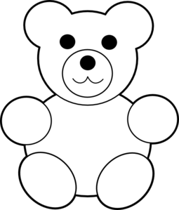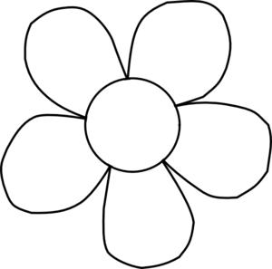
BROWN - YELLOW - PURPLE BLUE - GREEN - RED RED - ORANGE - WHITE
--------------------------------------------------------------------------------------------------------------------------------------
HOUSE SHOES PENCIL
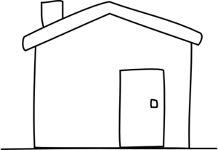
BLUE - PURPLE - PINK GREY - GREEN - BLACK YELLOW - ORANGE
--------------------------------------------------------------------------------------------------------------------------------------
FISH BIRD DOG
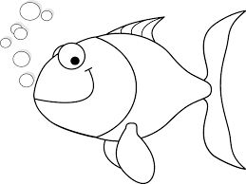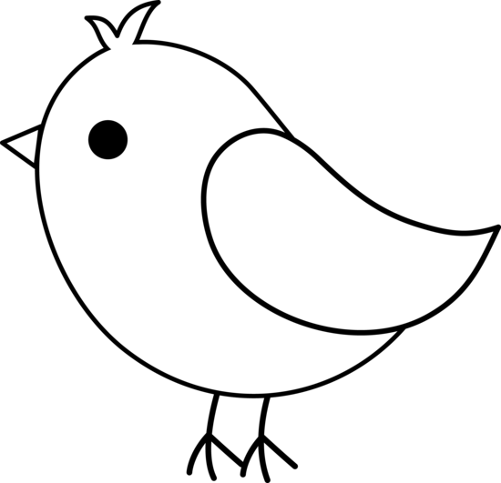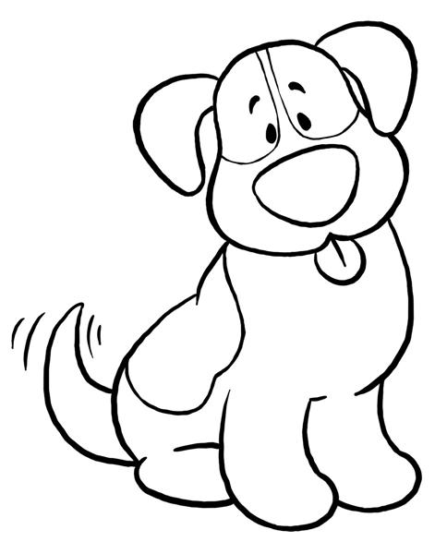
BLUE - RED - GREEN BROWN - YELLOW - ORANGE BLACK - BROWN - RED

STAR DOLL CAR
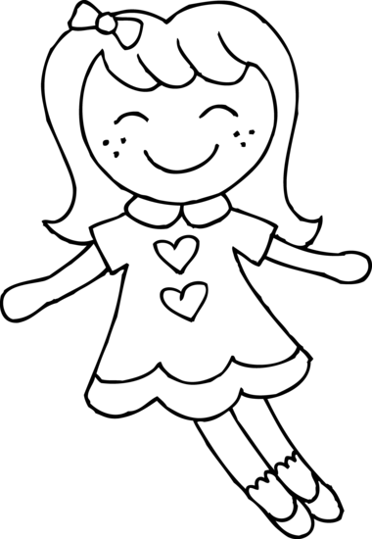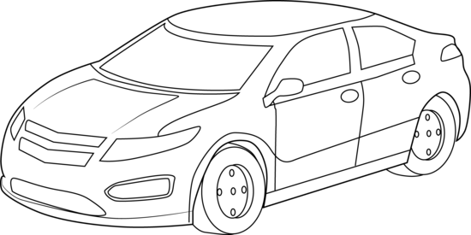
PINK YELLOW - BLUE - PINK RED - BLACK - BLUE
--------------------------------------------------------------------------------------------------------------------------------------
BOOK SCHOOL BAG CAKE
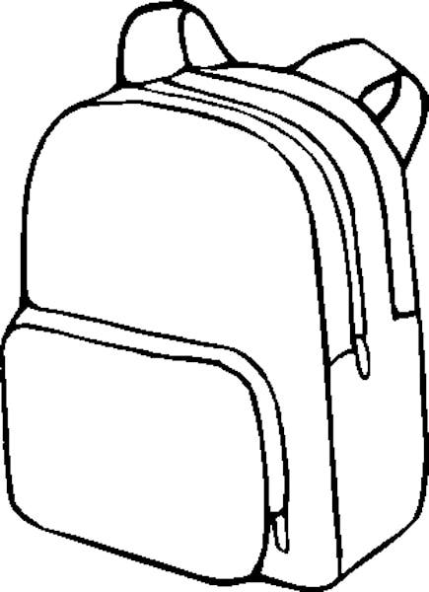
BROWN - RED - PURPLE BLUE - ORANGE - GREY YELLOW- PINK - RED
--------------------------------------------------------------------------------------------------------------------------------------
BALL CRAYONS BUS
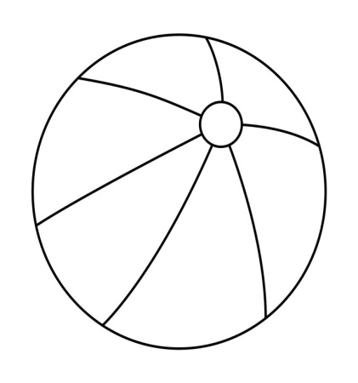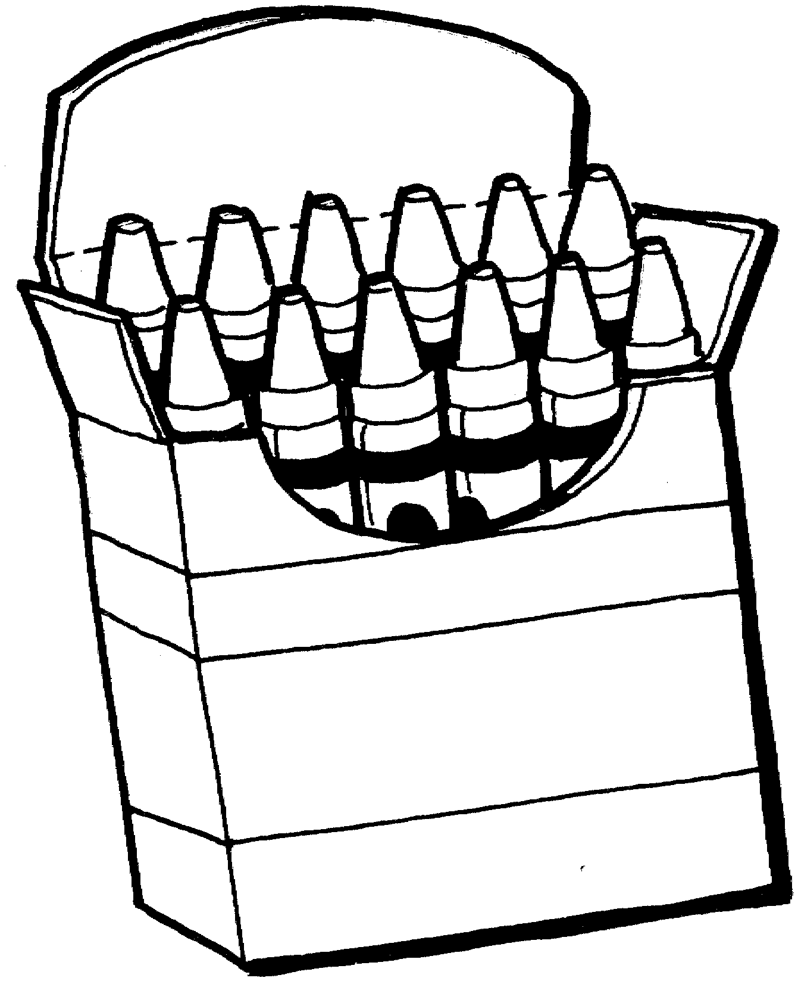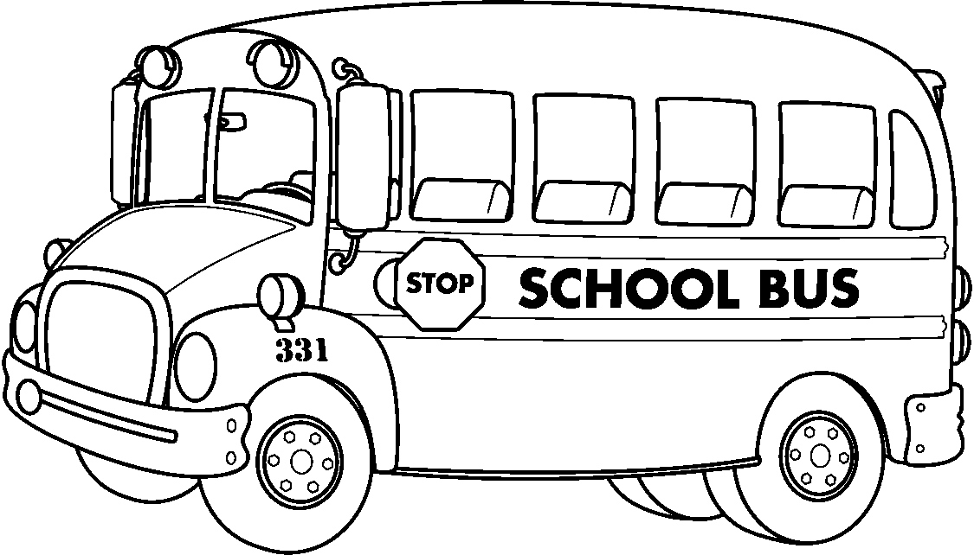
GREEN - WHITE - RED  YELLOW - BROWN - PURPLE

